Magnetic properties and geochemistry of loess/paleosol sequences at Nowdeh section northeastern of Iran
Feizi, Vahid *¹, Azizi , Ghasem ², Mollashahi, Maryam ³, Alimohammadian, Habib ⁴
- Ph.D. Dep. of Geography, Climatology, Tehran University, Vahid.feizi62@gmail.com
- Professor., Dep. of Geography, Climatology, Tehran University, ghazizi@ut.ac.ir
- Assistant Professor of Forestry in Arid regions, Faculty of Desert Study, Semnan University, Iranmaryam.mollashahi@semnan.ac.ir
- Assistance Prof, Environment Magnetic Laboratory, Dep. of Geology and Mineral Exploration halimohammadian@gmail.com
*-Corresponding Author: Feizi,Vahid. Email: vahid.feizi62@gmail.com Tell: 00989127985286

Abstract
The loess-paleosol sequences in the northeastern part of Iran serve as a high-resolution natural archive documenting climate and environmental changes. These sequences offer evidence of the interaction between the accumulation and erosion of aeolian and fluvial sediments during the Middle and Late Pleistocene periods. In this study, the Azadshar (Nowdeh Loess Section) site was chosen to reconstruct Late Quaternary climate shifts. The 24-meter thick Nowdeh loess/paleosol sequence was sampled for magnetic and geochemical analysis. The sampling involved 237 samples taken systematically at high resolution (10 cm intervals). The magnetic susceptibility of all samples was measured at the Environmental and Paleomagnetic Laboratory of the Geological Survey of Iran in Tehran. Selected samples, corresponding to peaks in magnetic susceptibility, underwent geochemical analysis to aid in the interpretation of paleoclimatic changes indicated by the magnetic signals. The magnetic susceptibility results of the loess/paleosol deposits revealed low values during cold and dry climate periods (Loess) and high values during warm and humid climate periods (paleosol). The comparison of magnetic and geochemical data showed that variations in geochemical weathering ratios corresponded to changes in magnetic parameters. A high level of correlation was observed between the magnetic susceptibility intensity and ratios such as Rb/Sr, Mn/Ti, Zr/Ti, and Mn/Sr.
Keyword: Loess/paleosols sequences, Climate, Magnetic parameters, Geochemical proxies, Northeastern of Iran.

Introduction
Reconstruction of the Quaternary climate is important for the development of climate models that lead to a better understanding of past and present and prediction of future climate development. Loess–paleosol sequences are now recognized as one of the most complete terrestrial archives of glacial–interglacial climate change (Porter, 2001; Muhs and Bettis, 2003, Pierce et al, 2011, Guo et al, 2002) and have been used to reconstruct climate and geomorphological changes ofduring the Quateary climate and geomorph; Frechen et al., 2003; Prins et al., 2007).

Loess deposits occur in large areas of the northeast, east central, north and central parts of Iran which is part of the loess belt that covers the Middle East and extends further northward into Turkmenistan, Qazakistan and Tajikistan (Okhravi and Amini, 2001).The extensive and thick loess deposits in northern Iran have been recently studied in detail establishing a more reliable chronological framework for the last interglacial/glacial cycle (Lateef, 1988; Pashaee, 1996; Kehl et al., 2006; Frechen et al., 2009, Karimi et al, 2009, Karimi et al, 2013, Okhravi and Amini, 2001, Mehdipour et al, 2012).
Paleoclimate studies of loess deposits based on rock magnetism and combined analyses of rock magnetism and geochemistry around the world have attained appreciable advances in the past few decades (Heller and Liu, 1984; Forster et al., 1996; Ding et al., 2002; Guo et al., 2002; Chlachula, 2011; Bronger, 2003; Baumgart et al., 2013, Guanhua, et al, 2014).
These studies comprise loess-paleosol records that cover Chinas loess plateaus, Germany, Poland, Tajikestan, Austrian, Ukraine, and the Danube catchment (Hosek et al, 2015,Ahmad and Chandra, 2013, Chen, 2010; Jordanova et al., 2011; Buggle et al., 2009; Fitzsimmons et al., 2012; Fischer et al., 2012; Jary and Ciszek, 2013; Baumgart et al., 2013; Schatz et al., 2014; Gocke et al., 2014).
Despite its suitable geographical location there is only a limited number of studies of loess deposits from the North of Iran. In this work
we explore the potential of loess deposits in northern Iran for reconstructing late quaternary climate/environmental change.

Study area
The Nowdeh section is exposed at about 20 km southeast of Gonbad-e Kavus and east of Azadshahr city. The Nowdeh river dissects a more than 24 m thick sequence of dull yellowish brown (10 YR 5/4) loess covering northeast dipping weathered limestone.
The study area (37° 05' 50" N and 55° 12' 58" E) is part of the Alborz structure and its sediment sheet is includes of north of Caspian Sea. This zone includes regions north of Alborz fault and south of Caspian Sea. Toward the east, the Gorgan-Rasht zone is covered with thick layers of loess.
The Nowdeh section was selected for this work due to earlier soil studies by Kehl et al (2005) and Frichen et al (2009) combined with the existence 12 dates for this section (Figure1).

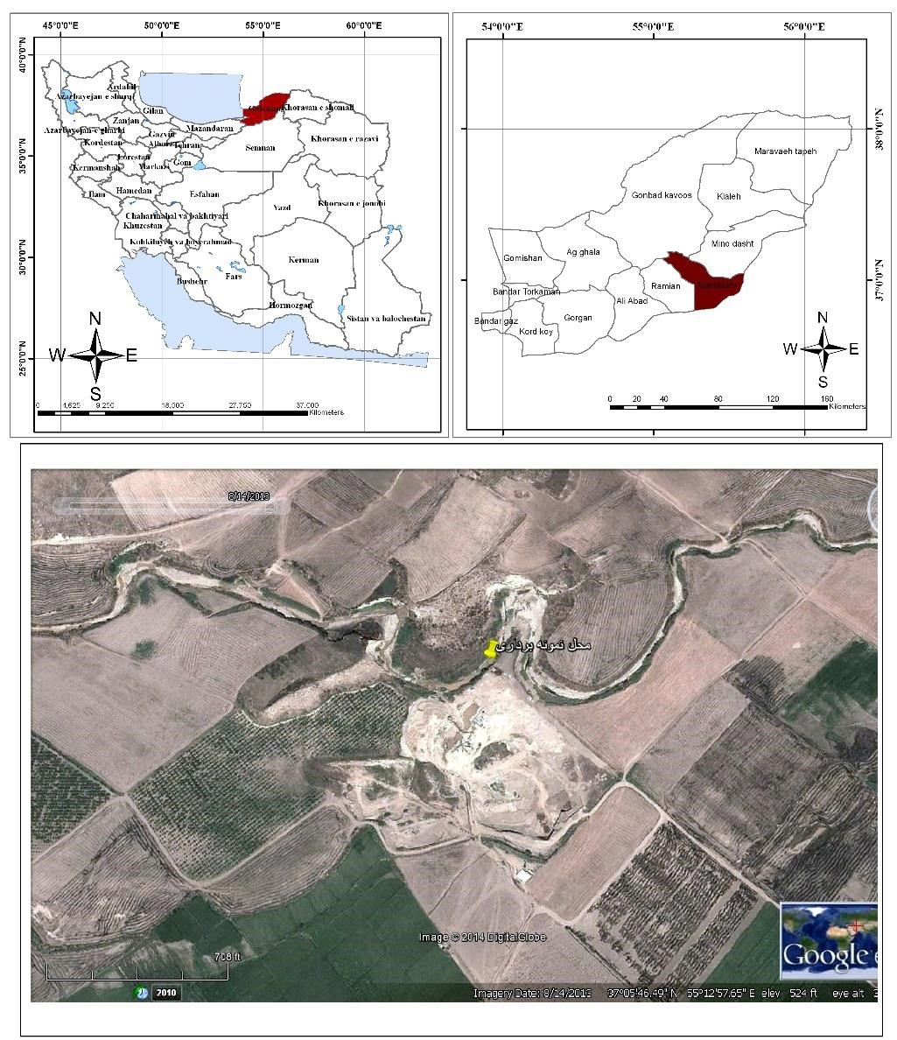

Figure 1: Map of Iran and the location of Nowdeh loess-paleosol sequence.
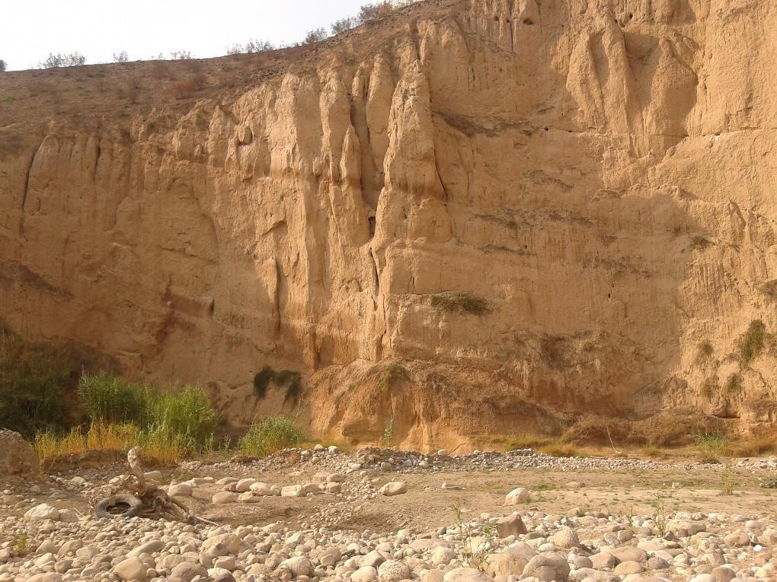

Figure 2: A view of the sedimentary section of the Nowdeh with its very clear layering.

Methodology

The Nowdeh loess section is approximately 24 meters thick and was sampled at 10 cm intervals for magnetometry and geochemical analysis. The sampling location and method were determined following a detailed study of the area. Magnetic susceptibility measurements of all samples were conducted at the Environmental and Paleomagnetic Laboratory of the Geological Survey of Iran in Tehran. Magnetic susceptibility is indicative of the collective response of diamagnetic, paramagnetic, ferrimagnetic, and imperfect antiferromagnetic minerals present in the samples. Each sample was placed in a 11 cm^3 plastic cylinder for use in magnetic measurement devices. The measurement of magnetic susceptibility was performed using the AGICO Kappabridge model MFK1-A .
The determination of Saturation Isothermal Remanent Magnetization (SIRM) was carried out to assess the concentration of ferromagnetic and imperfect antiferromagnetic minerals in the samples. The calculation of the Hard Isothermal Remanence (HIRM) magnetization was performed to identify magnetically significant components such as hematite in the samples using the following formula:
HIRM = 0.5(SIRM+ IRM−0.3T)
Where IRM−0.3T is the remanence after application of a reversed field of 0.3 T after growth and measurement of SIRM. The HIRM reflects the contribution specifically of the imperfect antiferromagnetic minerals hematite and goethite (Bloemendal et al., 2008).
The S−0.3T value, or S-ratio, is calculated as
S−0.3T = 0.5[(-IRM−0.3T/SIRM) + 1]
and it ranges from 0 and 100%. It reflects the ratio of ferrimagnetic to imperfect antiferromagnetic minerals (Bloemendal et al., 2008).
Based on the magnetic susceptibility results, 70 samples were selected for geochemical analyses (trace elements) to assist the paleoclimatic interpretation of the magnetic signals.
Here it would need a section on the age model – you do refer to ages in the next sections without having established how the chronology was determined.

Results Magnetic properties
In Figure 3, the relationship between susceptibility, NRM (Natural Remanent Magnetization), SIRM, HIRM, and S−0.3T in the Nowdeh section is illustrated. The variability in the magnetic susceptibility signal within the Nowdeh section indicates fluctuations in climate conditions and associated mechanisms during the Late Quaternary period. The values of magnetic susceptibility (χ) in the Nowdeh section range from 28.17 to 203.13 (in units of 10^-8 m^3 kg^-1). The maximum χ values (203.13) are found in the lower paleosol layer at 19.4 meters depth, while the minimum values are observed in the uppermost loess layer at 7.4 meters depth. The rock magnetic records exhibit a strong correlation with the lithology observed in the Nowdeh section. Generally, the paleosol layers exhibit higher magnetic signal intensities compared to the loess layers.
Following a relatively stable section between 22-23.7 meters figure 3 shows a significant minimum spike in magnetic susceptibility around 22.1 meters depth. Higher in the section, superimposed on a broader maximum, a series of high-amplitude oscillations occur between ~20.5 and 16m. Subsequently, the χ values decrease steadily from 16 to 10 meters depth, followed by another notable variation in χ from 10 to 8 meters depth.
The paleosols exhibit higher magnetic susceptibility (χ) values compared to the loesses, with magnified magnetic enhancement observed in the Bw, Bt, and Btk horizons, while the underlying C (loess) horizon displays lower χ values. This difference probably reflects precipitation of iron oxides in the Bw horizons, resulting in a higher concentration of pedogenetic magnetite in comparison to the C horizons (Jordanova et al., 2013; Hosek et al., 2015). The χ values in the lower and middle sections of the Nowdeh profile, approximately 53-80 and 120-140 thousand years ago (Ka), respectively, represent intermediate values between unweathered loesses and weathered paleosols.
The results indicate that the Natural Remanent Magnetization (NRM) is consistent with the variance in magnetic susceptibility, particularly notable at lower depths, with the highest recorded value of this parameter observed at 13.1 meters depth in the BW, BWK horizon (figure 3?). Variations and discrepancies in magnetic susceptibility align closely with the SIRM values of the Loess sequence. As magnetic susceptibility decreases, SIRM also shows a corresponding decrease. In the interval between 20 to 50 thousand years ago (ka), during which much of the upper Loess formation occurred, magnetic susceptibility shows minimal variation, a pattern mirrored in the SIRM diagram for this period. The elevated HIRM values in Figure 2 suggest an increase in the concentration and frequency of magnetic deterrent minerals such as Goethite, maghemite, or hematite.
The comparison between the lower values of saturation (S) (-0.3 T) (between 0.6 to
0.12 Am/m) and the higher values of Hard Isothermal Remanent Magnetization (HIRM) (between 2 to 5 Am/m) indicates that the proportion of minerals with lower saturation, such as magnetite, is significantly lower than the proportion of minerals with higher saturation in paleosols. This pattern contrasts with the composition of loess deposits.
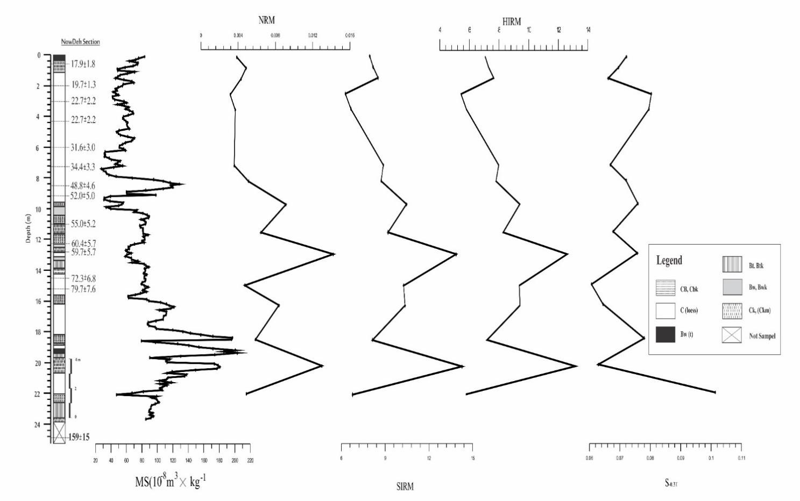

Figure 3: Basic magnetic parameters for Nowdeh section.

Element stratigraphy
Figure 4 illustrates the correlation between the concentration of selected elements (Sr, Rb, Zr, Ti, and Mn) and magnetite susceptibility in the Nowdeh section. The figure indicates significant variations in the concentration of these elements with noticeable differences between them. Sr and Rb exhibit similar trends along the Nowdeh section. At a depth of 2.9 meters, there is a notable increase in the concentration of these two elements, corresponding to an age of 22 thousand years ago (ka). Higher in the section, the concentration of Sr and Rb decreases.

The lower concentrations of elements were recorded at a depth of 8.5 meters, corresponding to an age of 48.8 thousand years ago (ka). Subsequently, there is no significant variation in the concentration of these elements until the depth of 18 meters, where the highest concentration of these elements is recorded in the Nowdeh section.
Ti, Zr, and Mn exhibit approximately similar trends in the diagram. These elements show little variation in concentration at the beginning of the section.
The variation in concentration of these elements begins to increase from a depth of 6.2 meters, corresponding to an age of 31.1 thousand years ago. It reaches the highest value in this zone and peaks at the depth of 8.5 meters (equivalent to 34.4 ka). This is followed by a decrease at the depth of 9.3 meters. These elements are the primary focus in this part of the Nowdeh section. There is little variation in the concentration of these elements up to a depth of 16.7 meters. From the depth of 16.7 meters to the bottom of the section, the concentration of elements exhibits a zig-zag pattern.
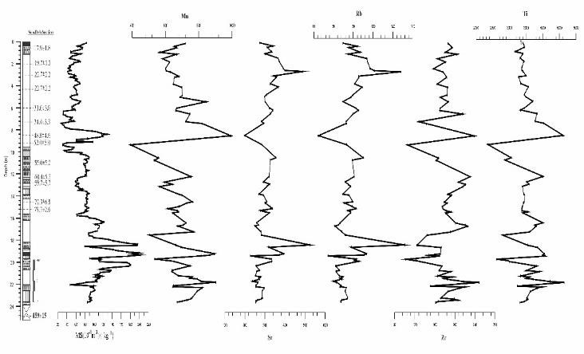

Figure 4: shows depth series of selected element concentrations for Nowdeh section. Trace element ratio
The variation of the Si/Ti ratio in figure 5 generally follows the magnetic susceptibility pattern (figure XXX), except for the lower part of the section (23-24 meters). The ratios of Mn/Sr, Zr/Ti, and Mn/Ti in figure 5 show almost no long term change, except for at a depth of 8.5 meters, corresponding to an age of 48.8 thousand years. The Rb/Sr ratio exhibits an opposite pattern to the magnetic susceptibility, especially at the depths of 8.5, 16, 19, and 22 meters. The Ba/Rb ratio generally follows the magnetic susceptibility pattern, except at depths of 13, 15, 19, and 22.8 meters where they vary oppositely.
The variation in the Si/Ti ratio does not exhibit a consistent relationship to the sequence of loess/palaeosol layers, as defined by the magnetic susceptibility, in the Nowdeh section. On the other hand, the Mn/Ti ratios tend to show elevated values in the palaeosols, likely due to the concentration of Mn oxide in the finer sediment fraction (Bloemendal et al., 2008). This suggests that the presence of Mn oxide plays a significant role in influencing the Mn/Ti ratio in the sediments, particularly in the palaeosol layers.
The Zr/Ti, Mn/Ti, Rb/Sr, and Mn/Sr records from the Nowdeh section exhibit a clear pattern of higher values prevailing in the palaeosols, and their high degree of similarity is noteworthy. Rb/Sr has been suggested by several researchers as an indicator of pedogenic intensity in loess, based on the differential weathering of the major host minerals, specifically K-feldspar for Rb and carbonates for Sr. In the case of Mn/Sr, the higher values observed in the palaeosols are likely a result of the combined effects of grain size on Mn concentration, as well as the loss of Sr through solution processes. This indicates that these ratios can serve as important indicators of pedogenic processes and weathering dynamics in the sedimentary record of the Nowdeh section.
In a study by Chen et al. (1999), a comparison was made between the Rb/Sr ratios and magnetic susceptibility values in the uppermost (last glacial/interglacial) sections of the Luochuan and Huanxian regions. The researchers noted a remarkable correspondence between the amplitudes of variation in magnetic susceptibility and Rb/Sr ratios. This finding suggests a close relationship between magnetic susceptibility variations and the Rb/Sr ratios in these regions during the last glacial and interglacial periods.
At a depth of 19.4 meters, which is commonly identified as a strongly developed palaeosol indicative of a past warm and humid climate, the magnetic susceptibility values are higher. Surprisingly, despite the indication of favorable climate conditions, the Rb/Sr ratios at this depth exhibit only moderate values. This discrepancy suggests that additional factors or processes may be influencing the Rb/Sr ratios in the sediments at this specific depth, potentially beyond the climatic conditions that typically lead to high Rb/Sr ratios in pedogenic sequences.

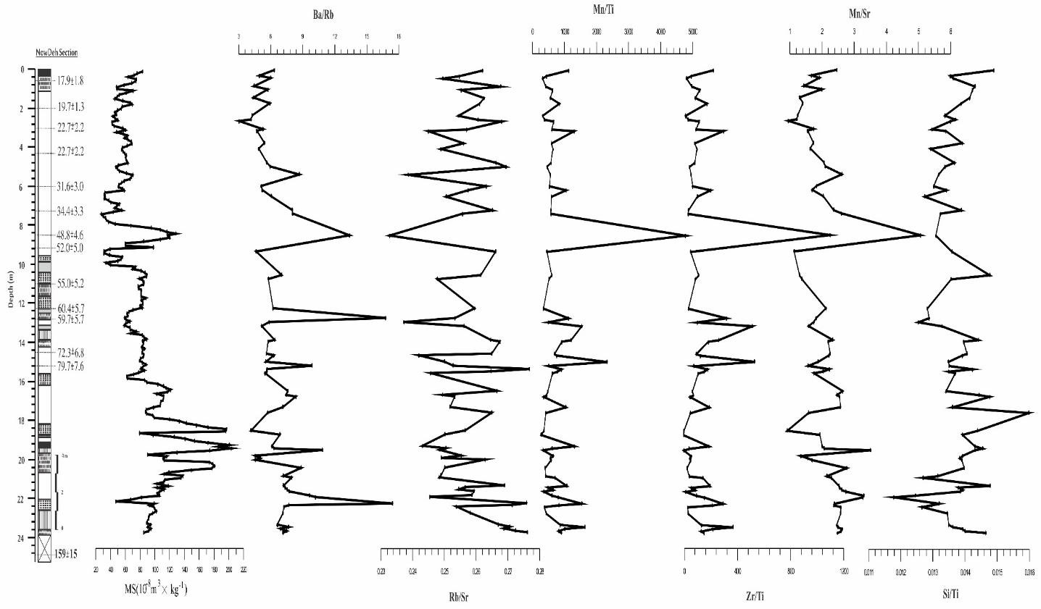

Figure 5: show selected element ratios in Nowdeh section

Discussion
Over the entire 159 Ka sequence at the Nowdeh site, there appears to be a reasonable first-order co-variation between the magnetic and geochemical indicators of weathering and soil formation, particularly with magnetic parameters reflecting variations in ferrimagnetic content and Sr-based ratios. However, upon closer detailed examination based on individual loess and palaeosol layers, an inconsistent relationship is observed between the amplitudes of individual peaks and troughs of magnetic and geochemical parameters. This suggests that while there is an overall correlation between these indicators at a broader scale, at a finer resolution within specific layers, the relationship becomes more complex and inconsistent. Additional factors or processes may be influencing the variations in magnetic and geochemical parameters within the individual stratigraphic units.
Therefore, it is possible that the suggestions by some researchers regarding a consistent response of loess magnetic mineralogical and geochemical properties to weathering and soil formation are valid for the post-159 Ka period.
To investigate the relationship between climate change and the magnetic properties of sediments, magnetic susceptibility measurements were conducted on loess sediments in the Nowdeh section. The results of the magnetic susceptibility analysis at Nowdeh revealed distinct sequences corresponding to cold and dry periods as well as warm and humid conditions (figure xxx) These variations in magnetic susceptibility align with the alternating Loess-paleosol sequences, indicating a relationship between the magnetic properties of the sediments and past climate changes in the Nowdeh region.
According to Song et al. (2008), sediment loess is formed under cold and dry climate conditions, leading to lower magnetic susceptibility due to the absence of significant weathering processes. In contrast, in paleosols formed as a result of pedogenic processes, the level of oxidation increases, resulting in an increase in magnetic susceptibility records due to higher concentrations of XYZ elements. It is widely observed, according to global standards, that in a loess/paleosol sequence, paleosols exhibit higher magnetic susceptibility than the adjacent loess layers (references).
The formation of strong magnetic minerals, such as iron oxides, in soils through pedogenesis processes includes minerals like Fe3O4, γ-Fe2O3, and Fe2O3 - . In contrast, the mineral magnetism of loess layers is influenced by the grain composition of the aeolian sources depositing the sediments. This distinction in magnetic mineral content between soils undergoing pedogenesis and loess layers sourced from aeolian deposits contributes to the differences in magnetic susceptibility observed between paleosols and loess layers in sediment sequences.
In Fig 3, the brown layer sequences of dark and light paleosols in the loess deposits demonstrate distinct weathering processes that closely resemble the patterns observed during glacial and interglacial periods in the middle and late Pleistocene. The paleosols in the Nowdeh section exhibit higher magnetic susceptibility compared to the surrounding loess layers. This difference is more prominent at lower depths, indicating greater weathering variability during those periods. At a depth of 21 meters, a significant decrease in magnetic susceptibility suggests a cold and dry season during that timeframe. The magnetic susceptibility chart for the Nowdeh section reveals approximately 8 distinct periods of increasing magnetic susceptibility, reflecting periods of temperature and humidity elevation. In accordance with the standard global loess characteristics, paleosols consistently exhibit higher magnetic susceptibility values compared to adjacent loess layers due to pedogenesis and oxidation processes, as highlighted by Maher (2011).
Loess units are typically formed during cold and dry conditions, and the mineral magnetic resources in these sediments are derived from aeolian sources. The increase in magnetic susceptibility observed in paleosols, along with the presence of mineral magnetic materials associated with aeolian deposits, suggests that the formation of iron oxide minerals in the sediments is influenced by the development of paleosols. Research studies and findings on magnetic susceptibility support this interpretation, as indicated by Maher (2011) and Spassov (2002).
In Figure 4, the magnetic susceptibility during cold glacial periods (corresponding to loess layer deposition) differs from that during warm interglacial periods (associated with paleosol formation). The NRM results suggest a decrease during loess formation and an increase during paleosol formation. This pattern suggests a relationship between NRM and magnetic susceptibility. A decrease in NRM indicates dry and cold weather conditions, consistent with the deposition of loess layers, while an increase in NRM represents warmer and more humid weather conditions, corresponding to paleosol formation.
The probable justifications for the low alteration in magnetic susceptibility and isothermal remnant magnetization between 20 to 50 thousand years ago can be attributed to two main factors:
- Decreased Pedogenesis due to cold and dry periods.
- Reduction in the influx of magnetic particles into loess layers.
During the last 20 thousand years, there seems to be a correlation between magnetic susceptibility variations in the surface soil layer and climatic conditions. This period coincides with the transition from cold weather to the current warm and humid climate in the northern region of Iran. As a result, the soil's magnetic properties, specifically the saturation isothermal remanent magnetization (SIRM), have likely increased during this time frame. However, since the SIRM samples were only collected at magnetic susceptibility peak points, they may not capture the full extent of variations. Comparing these findings with the research by Antoine et al. (2013) on loess/paleosol sediments in Central Europe reveals a close relationship, particularly around 32 thousand years ago. At this age, there appears to be evidence of a climate change event, marked by a decrease in magnetic susceptibility around 30 thousand years ago at the onset of loess deposition, indicating a cold and dry climate. Conversely, an increase in magnetic susceptibility around 32 thousand years ago suggests the onset of a warm and moist climate.
Geochemical charts can serve as useful indicators of weather patterns, as they can highlight different levels of weathering severity. In the study of loess deposits, certain chemical ratios can be utilized to reconstruct variations in paleoclimate (Ding et al., 2001).
Variations in the concentrations of manganese (Mn), zirconium (Zr), and titanium (Ti) in the soil reflect a clear stratigraphic pattern, with higher values seen in paleosols and lower values in the loess layers (Bloemendal et al., 2008). This pattern is influenced, in part, by carbonate dilution/concentration effects, as a significant portion of the variability in these elements disappears when expressed on a carbonate-corrected basis.
In the Nowdeh section, the amount of rubidium (Rb) in paleosols was lower compared to its concentration in loess layers. This discrepancy can be attributed to the higher solubility of Rb in warm and humid climates, typical of interglacial periods. Gallet et al. (1996) observed significant depletion of Rb in the paleosols, supporting this interpretation.
Our results indicate that the Mn/Ti, Zr/Ti, and Mn/Sr ratios tend to exhibit higher values in the paleosols. According to Ding et al. (2001), elevated Mn/Ti values in paleosols may result from the concentration of iron (Fe) and manganese (Mn) oxides in the finer sediment fractions. They also noted that the Rb/Sr and Mn/Sr ratios show a clear pattern of elevation in the paleosols, which aligns with the findings of our study. The Rb/Sr ratio has been proposed by various researchers as an indicator of pedogenic intensity in loess deposits, based on the differential weathering of major host minerals such as K-feldspar for Rb and carbonates for Sr. The higher Mn/Sr values in paleosols may be attributed to grain-size effects on Mn concentrations and the solubilization loss of Sr.
Chen et al. (1999) compared Rb/Sr and magnetic susceptibility in the uppermost parts of the Luochuan and Huanxian sections, revealing a significant correspondence between the variations in magnetic susceptibility and Rb/Sr ratios. This suggests a link between weathering intensity and magnetic properties in these sediments. In the context of the Nowdeh sedimentary section, the magnetic parameters were compared with those from other studies conducted in various regions of the world, further contributing to our understanding of paleoclimatic variations and weathering processes in loess deposits.
The comparison of magnetic receptivity results from the Nowdeh sedimentary section with the palynological data from sedimentary cores of Urmia Lake (Djamali et al., 2008) and the oxygen-18 isotope analysis from Arabian Sea sedimentary cores (Tzedakis, 1994) has provided valuable insights into past climate conditions.
In the analysis, an increase in the AP/NAP index in the lakes corresponded with the presence of ancient soil layers in the seedling sedimentary section. This increase signifies warmer temperatures and higher humidity levels, conducive to the growth of trees and shrubs. Conversely, a decrease in the AP/NAP index indicates a decline in temperature and humidity, leading to the disappearance of trees and shrubs and changes in surface vegetation cover. This correlation suggests that the climate conditions and their fluctuations in western Iran align with the sedimentary deposition at Nowdeh.
Moreover, the oxygen-18 isotope analysis of the Arabian Sea exhibited a strong agreement with magnetic receptivity data. A decrease in the oxygen-18 index points to warmer weather conditions, while an increase indicates colder conditions. The relationship between magnetic susceptibility and oxygen-18 levels in the Arabian Sea sediments, as shown in Figure 6, demonstrates that an increase in magnetic susceptibility corresponds with a decrease in oxygen-18 levels, indicating warmer climate conditions. This alignment further supports the connection between the recorded palynology data of Lake Urmia, oxygen-18 isotope data from the Arabian Sea, and the sequence of ancient loess-soil sediments in the Nowdeh sedimentary section.
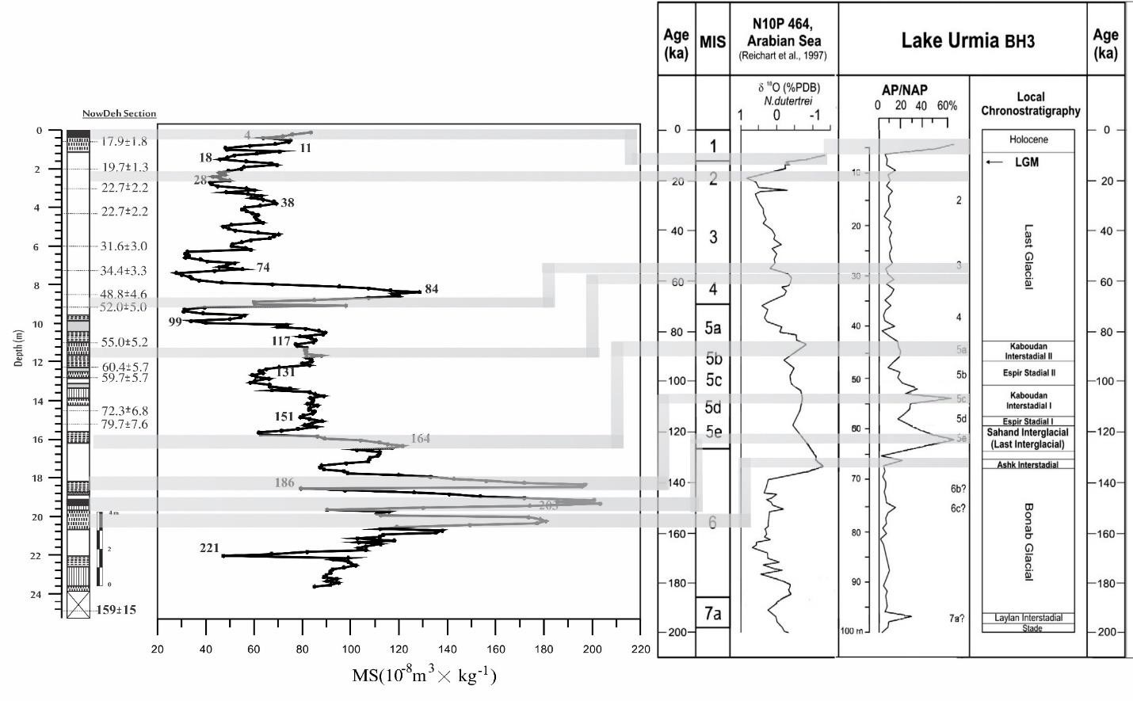

Figure 6: Correlation between recorded palynological data of Lake Urmia (Djamali et al, 2008) and oxygen isotope 18 of Arabian Sea sediments (Tzedakis, 1994) with the Loess-Paleosol sediment sequence of Nowdeh sedimentary section.
The results of your current research demonstrate a significant correlation with the studies conducted by Fuchs et al. in 2013 and Hosek et al. in 2015 on ancient loess/soil deposits in Central Europe. Figure 7 depicts consistent patterns in the magnetic receptivity parameter over the past 45, 73, 90, 104, and 108 thousand years across the study sections.
Around 45 and 73 thousand years ago, there is a clear increasing trend in magnetic receptivity observed in all analyzed layers, indicating a shift towards warmer and more humid climate conditions compared to earlier periods. This increase in magnetic susceptibility can be attributed to the higher presence of iron oxides in the soil resulting from increased chemical weathering.
Conversely, during the periods of 90, 104, and 108 thousand years ago, a decrease in magnetic receptivity is evident across all regions, signifying colder and drier climatic conditions during these time intervals.
While the older sediments also show a significant association with climate variations in Central Europe and the Nowdeh area, the absence of radiometric dating in these older sediments introduces some uncertainty when interpreting these findings.
Nonetheless, the consistent patterns in magnetic receptivity across different time periods provide valuable insights into past climate fluctuations and their impact on soil properties in these regions.
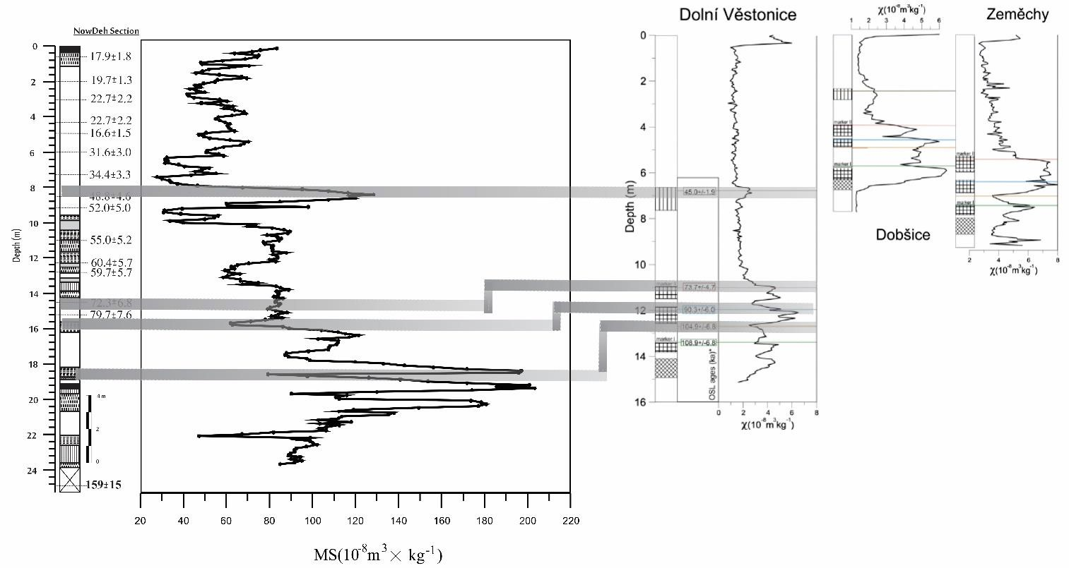

Figure 7: Comparison of changes in magnetic receptivity of Dolní Věstonice sedimentary section, Fuchs et al, 2013, Dobsice and Zemechy section, Hošek et al, 2015, with Nowdehh sedimentary section The comparison of magnetic receptivity trends as recorded in sedimentary sections of Beiyuan, Heimugou, Biampo, and the oxygen isotope records by Imbrie et al. (1984) in Figure 8 reveals a high agreement with the Nowdeh sedimentary section. This alignment indicates similar weather conditions across different locations in the Northern Hemisphere.
The consistency in magnetic receptivity trends among these various sites suggests a commonality in the climatic conditions experienced during the corresponding time periods. This synchronization in magnetic susceptibility patterns further supports the notion that these regions were subjected to comparable environmental changes and fluctuations in the past.
Additionally, the correlation observed between the magnetic receptivity data and the oxygen isotope records underscores the close relationship between climatic factors and sedimentary deposition patterns across these sites. By examining these geological proxies, researchers can gain valuable insights into the past climate dynamics and variations that have affected the Northern Hemisphere over time.
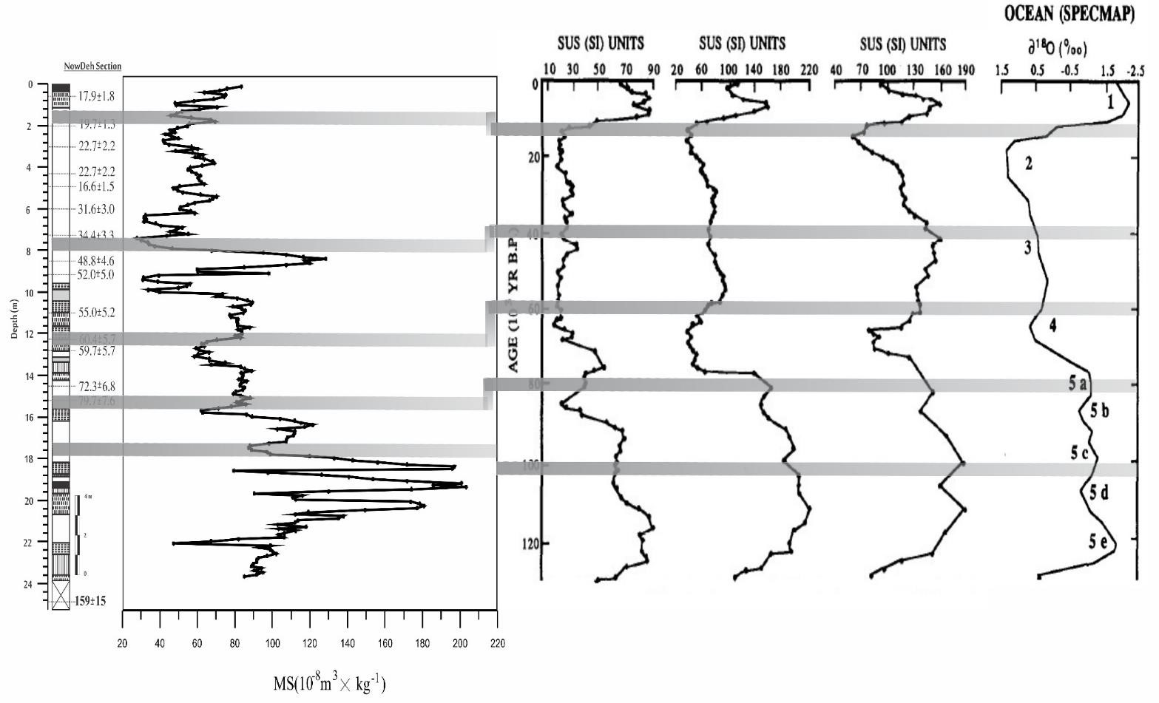

419

Figure 8: Comparison of magnetic receptivity changes of Beiyuan, Heimugou, Biampo, An et al, 1991, records of oxygen isotope 18 Imbrie et al, 1984 with Nowdeh sedimentary section
The findings of Mehdipour et al. in 2012 in the realm of fine loess exhibit a close resemblance to the results presented in our research, as illustrated in Figure 9. In their study, they employed both magnetic and geochemical approaches to assess different climatic periods, and the outcomes align significantly with the findings of your research. The comparison in Figure 9 reveals a strong consistency in the magnetic receptivity trends between the Nowdeh section and the Neka sedimentary section analyzed by Mehdipour et al. (year missing)
Between 48 and 20 thousand years ago, notable similarities are observed in the fluctuations of magnetic receptivity in both sedimentary sections. Whenever there is an increase in magnetic receptivity, it indicates a warm and humid period with the formation of ancient soil layers. This shared pattern implies a synchrony in climatic conditions between the two regions during this time frame, showcasing the utility of magnetic susceptibility as a proxy for understanding past environmental changes and soil development processes.
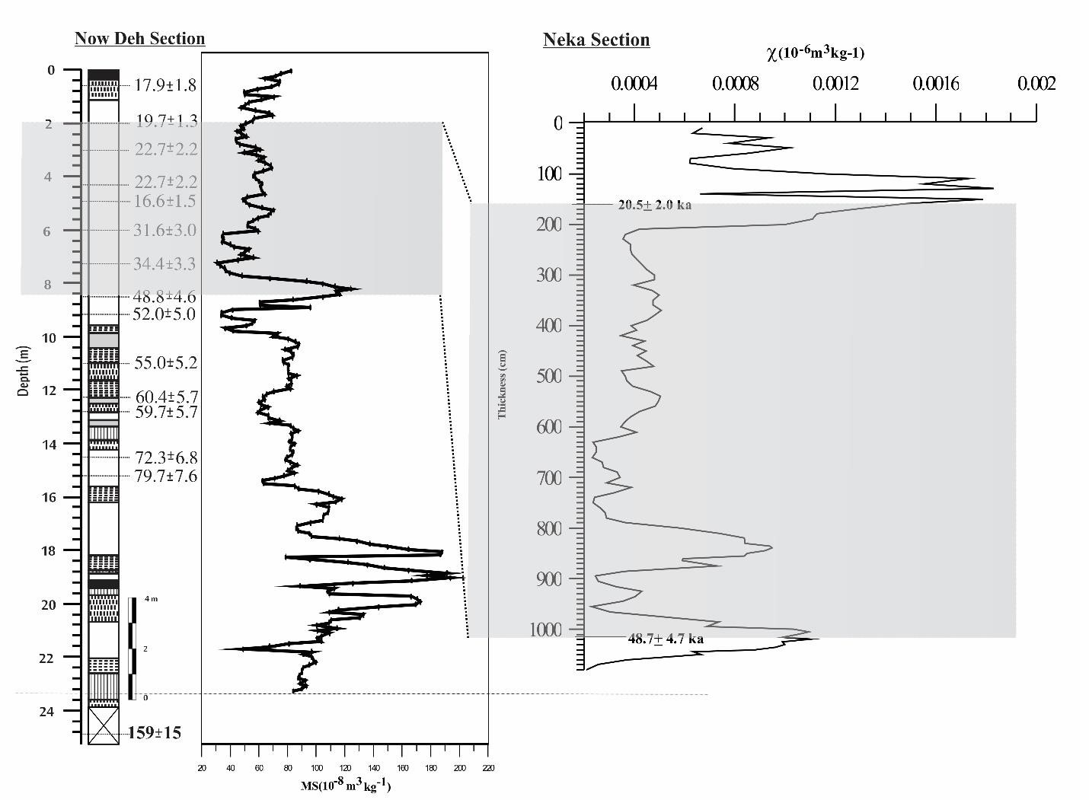

Figure 9: Comparison of magnetic receptivity diagram of Nowdeh sedimentary section with Neka sedimentary section (Mahdi et al., 2012)
The results of this research exhibit strong consistency with the findings of Beer and Sturm (1995) regarding beryllium saturation in the Zaifang sedimentary section and oxygen isotope 18 in marine sediments. In both cases, a clear correlation is observed between the fluctuations in beryllium saturation, oxygen isotope 18, and magnetic receptivity.
When beryllium saturation and oxygen isotope 18 decrease, there is a corresponding decrease in magnetic receptivity, indicating colder and drier weather conditions. Conversely, an increase in beryllium saturation and oxygen isotope 18 is accompanied by an increase in magnetic receptivity, signifying warmer and more humid periods.
The high agreement between the climatic periods identified based on these parameters in the Zaifang sedimentary section and marine sediments, and the magnetic receptivity trends observed in the Nowdeh sedimentary section, highlights the synchrony of similar weather events in the past across different locations. This consistency further supports the robustness of magnetic susceptibility as a proxy for understanding past climate variations and environmental changes.
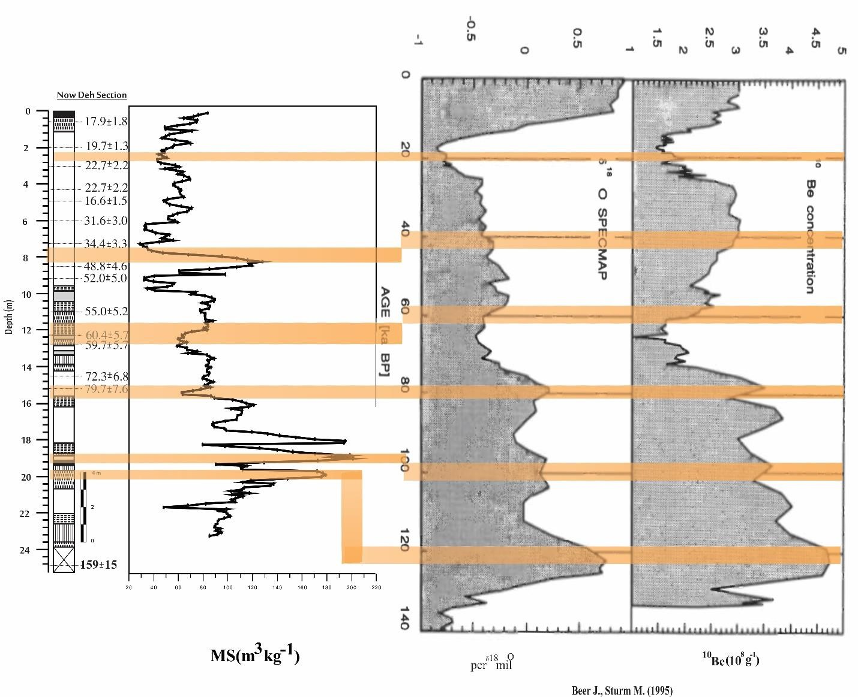

Figure 10: Comparison of magnetic receptivity results of Nowdeh sedimentary section in comparison with oxygen 18 and barium 10 isotope results of Xifeng sedimentary section (Beer and Sturm, 1995).

Conclusion
In conclusion, the loess/paleosol sequences from Northeastern Iran serve as a valuable archive for studying the paleoenvironmental changes during the Upper Pleistocene. By employing a multi-proxy approach that integrates sedimentological, magnetic, and geochemical methods, the following key insights have been revealed:
- The stratigraphy of the studied section aligns well with the typical pattern of Upper Pleistocene loess/paleosol successions in the region, providing valuable insights into the past environmental conditions.
- Magnetic parameters show a strong correlation with climate conditions, making them effective variables for reconstructing climate change patterns in the region.
- Comparisons between magnetic and geochemical data indicate that variations in geochemical weathering ratios mirror changes in magnetic weathering parameters, such as magnetic susceptibility, further enhancing our understanding of past environmental dynamics.
- The high degree of coherence observed between the amplitudes of magnetic susceptibility and various geochemical ratios, including Rb/Sr, Mn/Ti, Zr/Ti, and Mn/Sr, reinforces the reliability of magnetic susceptibility as a proxy for tracking environmental changes and provides additional insights into the interplay between magnetic and geochemical processes.
Overall, this comprehensive multi-proxy analysis enhances our understanding of the paleoenvironmental changes in Northeastern Iran during the Upper Pleistocene period and emphasizes the importance of integrating sedimentological, magnetic, and geochemical data to unravel past climatic fluctuations and environmental dynamics.

References
- Ahmad, I., Chandra, R, 2013, Geochemistry of loess-paleosol sediments of Kashmir Valley, India: Provenance and weathering, Journal of Asian Earth Sciences 66, 73-89.
- Antoine, P., Rousseau, D.D., Degeai, J.P., Moine, O., Lagroix, O., Kreutzer, S., Fuchs, M., Hatte, CH., Gauthier, C., Svoboda, J, and Lisa , l., 2013, High-resolution record of the environmental response to climatic variations during the Last Interglacial Glacial cycle in Central Europe: the loess-palaeosol sequence of Dolní V_estonice (Czech Republic), Quaternary Science Reviews, 67, PP 17-38.
- Baumgart, P., Hambach, U., Meszner, S., Faust, D., 2013. An environmental magnetic fingerprint of periglacial loess: records of Late Pleistocene loess paleosol sequences from Eastern Germany. Quat. Int. 296, 82–93.
- Bloemendal, J., Xiuming L., Youbin, S., Ningning L., 2008. An assessment of magnetic and geochemical indicators of weathering and pedogenesis at two contrasting sites on the Chinese Loess plateau, Palaeogeography, Palaeoclimatology, Palaeoecology 257 ; 152– 168.
- Bronger, A., 2003. Correlation of loess-paleosol sequence in East and Central Asia with SE Central Europe: toward a continental Quaternary pedostratigraphy and paleoclimate history. Quaternary International 106/107, 11–31.
- Buggle, B., Hambach, U., Glaser, B., Gerasimenko, N., Markovic, S., Glaser, I., Zöller, L., 2009. Stratigraphy, and spatial and temporal paleoclimatic trends in Southeastern/Eastern European loess–paleosol sequences. Quat. Int. 196, 186–206.
- Chen, J., An, Z.S., Head, J., 1999. Variation of Rb/Sr ratios in the loess–paleosol sequences of central China during the last 130,000 years and their implications for monsoon paleoclimatology. Quaternary Research 51, 215–219.
- Chen, T., Xie, Q., Xu, H., Chen, J., Ji, J., Lu, J., Lu, H and Balsam, W, 2010, Characteristics and formation mechanism of pedogenic hematite in Quaternary Chinese loess and paleosols, Catena 81, 217-225.
- Chlachula, J., Little, E., 2011, A high-resolution Late Quaternary climatostratigraphic record from Iskitim, Priobie Loess Plateau, SW Siberia, Quaternary International 240 , 139e149
- Ding, Z.L., Ranov, V., Yang, S.L., Finaev, A., Han, J.M., Wang, G.A., 2002. The loess record in southern Tajikistan and correlation with Chinese loess. Earth and Planetary Science Letters 200, 387e400.
- Ding, Z.L., Yang, S.L., Sun, J.M., Liu, T.S., 2001. Iron geochemistry of loess and Red Clay deposits in the Chinese Loess Plateau and implications for long-term Asian monsoon evolution in the last 7.0 Ma. Earth and Planetary Science Letters 185, 99–109.
- Fischer, P., Hilgers, A., Protze, J., Kels, H., Lehmkuhl, F., Gerlach, R., 2012. Formation and geochronology of Last Interglacial to Lower Weichselian loess/palaeosol sequences — case studies from the Lower Rhine Embayment, Germany. E & G Quat.Sci. J. 61, 48– 63.
- Fitzsimmons, K.E., Marković, S.B., Hambach, U., 2012. Pleistocene environmental dynamics recorded in the loess of the middle and lower Danube Basin. Quat. Sci. Rev. 41,104–118.
- Forster, T., Evans, M.E., Havlíček, P., Heller, F., 1996. Loess in the Czech Republic:magnetic properties and paleoclimate. Stud. Geophys. Geod. 40, 243–261.
- Frechen, M., Kehl, M., Rolf, C., Sarvati, R., Skowronek A., 2009, Loess Chronology of the Caspian Lowland in Northern Iran, Quaternary International, No. 198, pp. 220-233.
- Frechen, M., Oches, E.A., Kohfeld, K.E., 2003. Loess in Europe—mass accumulation rates during the Last Glacial Period. Quaternary Science Reviews 22, 1835–1875.
- Gallet, S., Jahn, B.M., Torii, M., 1996. Geochemical characterization of the Luochuan loess-paleosol sequence, China, and paleoclimatic implications. Chemical Geology 133, 67–88.
- Gocke, M., Hambach, U., Eckmeier, E., Schwark, L., Zöller, L., Fuchs, M., Löscher, M., Wiesenberg, G.L.B., 2014. Introducing an improved multi-proxy approach for paleoenvironmental reconstruction of loess–paleosol archives applied on the Late Pleistocene Nussloch sequence (SW Germany). Palaeogeogr. Palaeoclimatol. Palaeoecol. 410, 300–315.
- Guanhua. L, Dunsheng. X, Ming. J, Jia. J, Jiabo. L, Shuang Z,Yanglei. W, 2014, Magnetic characteristics of loessepaleosol sequences in Tacheng, northwestern China, and their paleoenvironmental implications, Quaternary International, 3, 1-10.
- Guo, Z.T., Ruddiman, W.F., Hao, Q.Z., Wu, H.B., Qiao, Y.S., Zhu, R.X., Peng, S.Z., Wei, J.J., Yuan, B.Y., and Liu, T.S., 2002. Onset of Asian desertification by 22 Myr ago inferred from loess deposit in China. Nature Vol. 416, pp. 159–163.
- Heller, F., Liu, T., 1984. Magnetism of Chinese loess deposits. Geophys. J. R. Astron. Soc. 77, 125–141.
- Hošek, J. Hambach, U. Lisá, L. Matys G. T. Horáček, I., 2015, an integrated rock-magnetic and geochemical approach to loess/paleosol sequences fromBohemia andMoravia (Czech Republic): Implications for the Upper Pleistocene paleoenvironment in central Europe, Palaeogeography, Palaeoclimatology, Palaeoecology 418, 344–358.
- Jary, Z., Ciszek, D., 2013. Late Pleistocene loess–palaeosol sequences in Poland and western Ukraine. Quat. Int. 296, 37–50.
- Jordanova, D., Grygar, T., Jordanova, N., Petrov, P., 2011. Palaeoclimatic significance of hematite/goethite ratio in Bulgarian loess–palaeosol sediments deduced by DRS and rock magnetic measurements. In: Petrovsky, E., Ivers, D., Harinarayana, T., Herrero- Bervera, E. (Eds.), the Earth's Magnetic Interior. IAGA Special Sopron Book Series. SpringerVerlag, Berlin.
- Karimi, A., Khademi, H., Ayoubi, A., 2013, Magnetic susceptibility and morphological characteristics of a loess–paleosol sequence in northeastern Iran, Catena, 101, pp. 56-60.
- Karimi, A., Khademi, H., Jalalian, A., 2011, Loess: Characterize and application for paleoclimate study, Geography Research,Volume 76, pp1-20.
- Karimi, A., Khademi, H., Kehl, M., Jalaian, A., 2009, Distribution, Lithology and Provenance of Peridesert Loess Deposits in Northeast Iran, Geoderm, No.148, pp. 241250.
- Kehl, M., Frechen, M., Skowronek, A., 2005, Paleosols Derived from Loess and Loesslike Sediments in the Basin of Persepolis, Southern Iran, Quaternary International, No.140/141, pp.135-149.
- Kehl, M., Sarvati, R., Ahmadi, H., Frechen, M., Skowronek, A., 2006, Loess / Paleosolsequences along a Climatic Gradient in Northern Iran, Eisxeitalter und Gegenwart, No. 55, pp.149-173.
- Lateef, A.S.A., 1988. Distribution, provenance, age and paleoclomatic record of the loess in Central North Iran. In: Eden, D.N., Furkert, R.J. (Eds.), Loess – its Distribution, Geology and Soil. Proceeding of an International Symposium on Loess, New Zealand, 14–21 February 1987. Balkema, Rotterdam, pp. 93–101.
- Mehdipour, F, 2012, Investigation of paleoclimate in late quaternary western alborz using of technical applied and magnetism parameters, Geology and Mineral Exploration, master science thesis.
- Nabavi, Mehdi, 1976, Introduction geology of Iran, pp1-109.
- Okhravi, R. Amini, A., 2001, Characteristics and Provenance of the Loess Deposits of the Gharatikan Watershed in Northeast Iran, Global and Planetary Change, No. 28, pp.11-22.
- Pashaei, A., 1996, Study of Chemical and Physical and Origin of Loess Deposits in Gorgan and Dasht Area, Earth Science, 23/24, pp. 67-78.
- Prins, M.A., Vriend, M., Nugteren, G., Vandenberghe, J., Huazu, L., Zheng, H., Weltje, G.J., 2007. Late Quaternary aeolian dust input variability on the Chinese Loess Plateau: inference from unmixing of loess grain-size record. Quaternary Science Reviews 26, 230– 242.
- Schatz, A.-K., Scholten, T., Kühn, P., 2014. Paleoclimate and weathering of the Tokaj (NE Hungary) loess–paleosol sequence: a comparison of geochemical weathering indices and paleoclimate parameters. Clim. Past Discuss. 10, 469–507.
- Song, Y., Shi, Z., Dong, H., Nie, J., Qian, L., Chang, H. & Qiang, X., 2008- Loess Magnetic Susceptibility in Central Asia and its Paleoclimatic Significance. IEEE International Geoscience & Remote Sensing Symposium, II 1227-1230, Massachusetts.
- Spassov, S., 2002. Loess Magnetism, Environment and Climate Change on the Chinese Loess Plateau. Doctoral Thesis, ETH Zürich, pp. 1–151.
- Taylor, S.R., McLennan, S.M., McCulloch, M.T., 1983. Geochemistry of loess, continental crustal composition and crustal model ages. Geochimica et Cosmochimica Acta 47, 1897– 1905.

