Rationale for changes in the content of this paper.
[Note to editor: The changes listed below are slightly different from those we sent earlier because to avoid making further changes to the MS we reverted to the Cui and Schubert (2018) estimate for latest Paleocene CO2 (excluding the low value noted in the text). With hindsight, we should have used the estimates from Hollis et al. (2019), which leads to a slightly higher average value. But it makes little difference to the end result.]
In checking the proofs, an error was discovered in the way CO₂ estimates were derived. This led to further checking, and we found two further errors. We have rectified these errors with the following changes to the text, Table 1 and Figure 14. The first error occurred when we sought to calculate CO₂ using n-alkane and fatty-acid δ¹³C. We added 4 ‰ to the values to account for the ~4 ‰ lipid–leaf offset (Diefendorf et al., 2015). However, we also subtracted 4 ‰ from the reference value, which was an error. When we recalculated, we obtained untenably high CO₂ values (pre-WOF values of 2000–5000 ppm), which caused us to question our choice of reference value. When we substituted, the reference value from China (Chen et al. 2014) for local reference values (Inglis et al. 2021), which included both bulk OM and n-alkane δ¹³C, we obtained more realistic CO₂ estimates. While re-checking the calculations, we also found that we had not screened the mid-Waipara fatty-acid data adequately. We had included relatively low TOC samples in the WOF samples and lower Paleocene samples in the pre-WOF samples. Applying criteria more comparable with the screening used for the n-alkane data from the Taylor White section, resulted in similar mean δ¹³C values for the two sections, and therefore closer alignment in CO₂ estimates. The samples selected for this analysis are indicated in revised Tables S5 and S6.
P1, Line (L) 8. enriched in ¹³C (remove the δ here) [The error in this formulation was pointed out by one reviewer. Sediments can be enriched in 13C (i.e. more 13C than typical) but cannot be enriched in delta 13C, which is a ratio.]
P1, L19. Change “~3‰” to “~2.5‰”. [This change relates to better screening of the mid-Waipara samples]
P1, L24. Change “40%” to “35%”. [This change relates to our corrections in estimating CO₂]
P16, L8–L15. Delete the two sentences from “For the lipid biomarker calculations …” to “… (Chen et al., 2014).” and replace with “For our latest Paleocene (t=0) δ¹³C values, we use the mean bulk and HMW n-alkane δ¹³C values from coal samples in the uppermost Paleocene in the Canterbury (New Zealand) Otaio River section (Inglis et al., 2021). In the absence of fatty acid δ¹³C data for this section, we use the n-alkane data as reference for both n-alkanes and fatty acid δ¹³C.” [This change simply states that we use Otaio as our latest Paleocene reference site. This keeps changes to the text to the minimum. We don’t need to make any reference to the site in China or the 4 ‰ offset because we can base our calculations of the bulk and n-alkane δ¹³C values from Otaio].
P16, L19. Change 2.6‰ to 2.2‰ and -31.6‰ to -30.4‰. [These changes reflect improved data screening for mid-Waipara].
P16, L20. Change -29‰ and -28.2‰. [This change reflects improved data screening for mid-Waipara].
P16, L25. Change -27.9‰ to -27.45‰. [This change is a simple typing error. Calculations have used this value]
P16, L30. Correct this value to 2.5‰ [This change reflects improved data screening for mid-Waipara, which reduces the mean excursion by 0.5. ‰]
P16, L33. Correct this value to 2.5‰. [Follows on from the above]
P16, L34. Correct this value to -18.5‰. [Follows on from the above]
P17, L1. Correct this value to ~1.5‰. [Follows on from the above]
P17, L6. Correct the range to 145 to 318 ppm. [This is the result of correcting the CO2 calculations]
P17, L7. Correct the range to 203 to 484 ppm. [This is the result of correcting the CO2 calculations]
P17, L8. Correct the range to 28%–43%. [This is the result of correcting the CO2 calculations]
P17, L13–15. Replace the sentence “Nevertheless, the …. Waipawa deposition” with “On average, the different approaches indicate that a ~35% decrease in CO₂ may be linked to Waipawa deposition”. [Because there is greater variation in CO2 estimates, we felt the framing of the sentence using “nevertheless” and “consistent” should be change to a simple “on average” statement]
P17, L19. Change ~40% to ~35% and ~2.5 to ~3. [This is the result of correcting the CO2 calculations]
P17, L20. Change 40% to 35%.
P17, L21. Change 2.5°C to 3°C.
P17, L30–L31. Replace “terrestrial OM and n-alkanes” with “n-alkanes and fatty acids”. [This is because the new CO₂ estimates are more concordant for n-alkanes and fatty acids, whereas the OM estimate is significantly lower]
P17, L32. Replace “200-300 ppm” with “~300 ppm”. [This is the average of the n-alkane and fatty acid estimates (274 and 318 pm)]
P17, L34. Please add this sentence to the end of this paragraph. “The low CO₂ estimates derived from terrestrial OM suggest that we may have underestimated the degree to which lignin degradation has affected the δ¹³C of OM in both Waipawa organofacies and underlying sediments.” [This sentence explains why we have greater confidence in the lipid-based estimates]
P18, L45-49. Please revise this sentence to: “The foraminiferal data imply that this runoff event occurred while the East Coast Basin was progressively deepening as part of long-term passive margin subsidence throughout New Zealand (King et al., 1999).” [In proof-reading this sentence we noted that it was somewhat tautological as formulated. The deepening is not consistent with subsidence, it is the primary evidence for subsidence.]
P20, L12. Replace “recorded by mid-Waipara HMW fatty acids” with “observed in New Zealand”. [We changed this wording because we’re not sure why we restricted this comparison to the mid-Waipara HMW fatty acids. The comparison applies to all the NZ records examined.]
P21, L22. Please revise the last two sentences of this section to: “The eastern margin of Tasmania has a similar geological history (Hill and Exon, 2004). The most plausible explanation for both regions experiencing a major episode of terrestrial runoff in the early late Paleocene (Bijl et al., 2021) is a eustatic fall in sea level, eroding coastal vegetation and flushing the debris into offshore basins.” [The previous wording was a little ambiguous. We changed the wording to make it clearer that the two regions experienced this unusual event, and change “only plausible” to “most plausible” because there may be other plausible explanations that we haven’t considered. Note the year “2019” is missing from the Naeher et al., 2019 ref.]
P22, L96. Please delete this reference: Chen et al., 2014.

Table 1. Note that we also neglected to add the units for this table. Please add these units to the column labels (Please also revise the label for δ¹³C_{CO2} as indicated):

Table 1. Parameters used to derive atmospheric CO2 estimates for Waipawa and underlying organofacies
 | Age (Ma) | δ¹³C (‰) ª | δ¹³C_{CO2} (‰) ^{b} | Δ(Δ¹³C) (‰) ^{c} | CO₂ (ppm) ^{c} | % Decrease ^{d} | Sensitivity ^{e}
Terrestrial OM
Pre-PETM (t = 0) | 56.2-56.0 | -24.50 | -5.70 |  | 432
OM-rich WOF | 59.2-59.0 | -18.50 | -4.90 | -5.45 | 145 | 28 | 3.5
Pre-WOF | 59.8-59.6 | -21.00 | -5.50 | -3.46 | 203
N-alkanes
Pre-PETM (t = 0) | 56.2-56.0 | -29.90 | -5.70 |  | 432
OM-rich WOF | 59.2-59.0 | -27.45 | -4.90 | -1.76 | 274 | 43 | 2.3
Pre-WOF | 59.8-59.6 | -30.70 | -5.50 | 1.07 | 484
Fatty acids
Pre-PETM (t = 0) | 56.2-56.0 | -29.90 | -5.70 |  | 432
OM-rich WOF | 59.2-59.0 | -28.20 | -4.90 | -0.97 | 318 | 30 | 3.4
Pre-WOF | 59.8-59.6 | -30.40 | -5.50 | 0.73 | 451
Notes
ª Pre-PETM values from Inglis et al. (2021). ^{b} Calculated from Westerhold et al. (2020) using method of Tipple et al. (2010). ^{c} Pre-PETM values from Cui and Schubert (2018), Waipawa organofacies (WOF) and pre-WOF values calculated using equations (1) and (2) from Cui and Schubert (2016). ^{d} Percentage decrease in CO₂ in Waipawa organofacies (average value = 35%). ^{e} Decrease in temperature (°C) with one halving of CO₂ (average value = 3).

Revised Figure 14 (note revision to caption (highlighted)

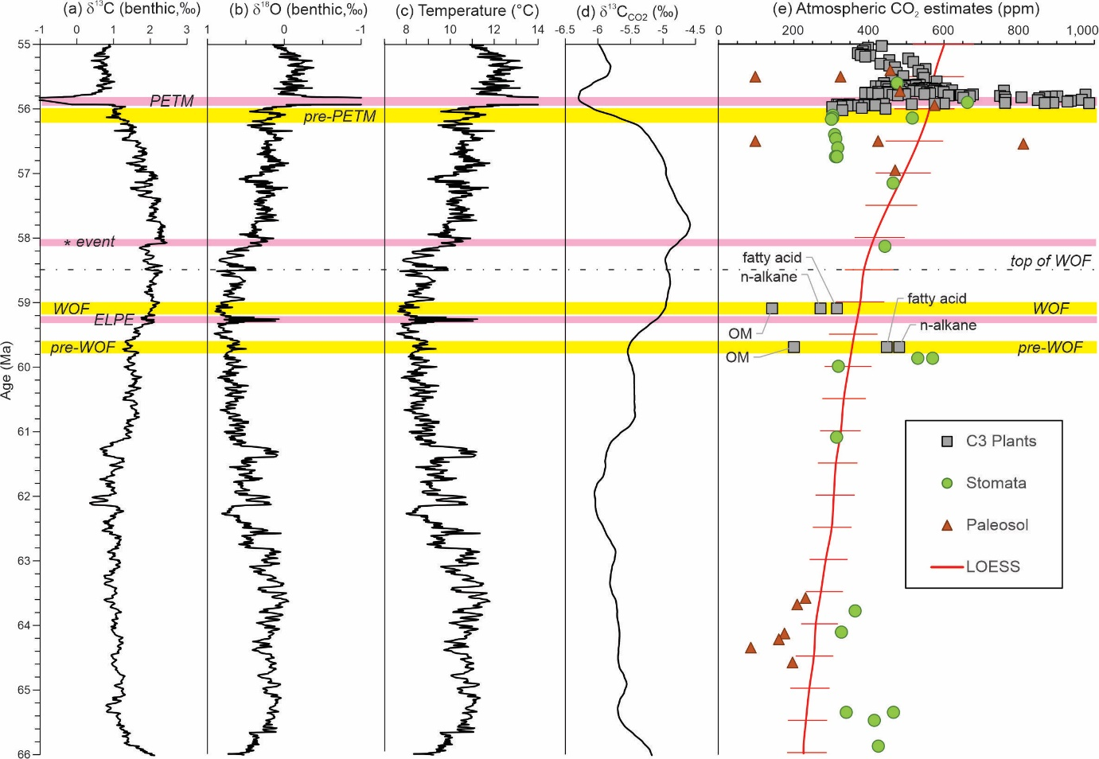

Figure 14. Compilation of early Paleogene variation in deep-sea benthic foraminiferal (a) carbon and (b) oxygen isotopes (LOESS smoothed curves from Westerhold et al. 2020), (c) oxygen isotope-based temperatures, (d) carbon isotope values for atmospheric CO₂ and (e) estimates for atmospheric CO₂ volume (Hollis et al., 2019; after Foster et al., 2017). Horizontal pink bands – hyperthermals or carbon isotope excursion; horizontal yellow bands – reference time slices for CO₂ determinations; WOF indicates Waipawa organofacies.

