**THE LAST GLACIAL TERMINATION ON THE EASTERN FLANK OF THE CENTRAL PATAGONIAN ANDES (47°S)**

William I. Henríquez1,2, Rodrigo Villa-Martínez3, Isabel Vilanova4, Ricardo De Pol-Holz3, and Patricio I. Moreno2,*

1Victoria University of Wellington, Wellington, New Zealand

2Instituto de Ecología y Biodiversidad, Departamento de Ciencias Ecológicas, Universidad de Chile, Casilla 653, Santiago, Chile

3GAIA-Antártica, Universidad de Magallanes, Avda. Bulnes 01855, Punta Arenas, Chile 4Museo Argentino de Ciencias Naturales Bernardino Rivadavia, Avda. Angel Gallardo 470, Buenos Aires, Argentina.

*Corresponding author: pimoreno@uchile.cl

ABSTRACT

Few studies have examined in detail the sequence of events during the last glacial termination (T1) in the core sector of the Patagonian Ice Sheet (PIS), the largest ice mass in the Southern Hemisphere outside Antarctica. Here we report results from Lago Edita (47°8’S, 72°25’W, 570 m.a.s.l.), a small closed-basin lake located in a valley overridden by eastward-flowing Andean glaciers during the Last Glacial Maximum (LGM). The Lago Edita record shows glaciolacustrine sedimentation until 19,400 yr BP, followed by a mosaic of cold-resistant, hygrophilous conifers and rainforest trees, along with alpine herbs between 19,400-11,000 yr BP. Our data suggest that the PIS retreated at least ~90 km from its LGM limit between ~21,000-19,400 yr BP and that scattered, low-density populations of cold-resistant hygrophilous conifers, rainforest trees, high Andean and steppe herbs thrived east of the Andes during the LGM and T1, implying high precipitation and southern westerly wind (SWW) influence at 47°S. The conifer *Podocarpus nubigena* increased between 14,500-13,000 yr BP suggesting stronger SWW influence at 47°S during the Antarctic Cold Reversal, after which declined and persisted until 11,000 yr BP. Large increases in arboreal pollen at ~13,000 and ~11,000 yr BP led to the establishment of forests near Lago Edita between 10,000-9000 yr BP, suggesting a rise in the regional treeline along the eastern Andean slopes driven by warming pulses at ~13,000 and ~11,000 yr BP and a subsequent decline in SWW influence at ~11,000 yr BP. We propose that the PIS imposed a regional cooling signal along its eastern, downwind margin through T1 that lasted until the separation of the North and South Patagonian icefields along the Andes during the Younger Dryas period. We posit that the withdrawal of glacial and associated glaciolacustrine environments through T1 provided a route for the dispersal of hygrophilous trees and herbs from the eastern flank of the central Patagonian Andes, contributing to the afforestation of the western Andean slopes and pacific coasts of central Patagonia during T1.

INTRODUCTION

The Patagonian ice sheet (PIS) was the largest ice mass in the southern hemisphere outside Antarctica during the last glacial maximum (LGM). Outlet lobes from the PIS flowed westward into the Pacific coast south of 43ºS and eastward toward the extra-Andean Patagonian plains, blanketing a broad range of environments and climatic zones across and along the Andes. Land biota from formerly ice-free sectors underwent local extinction or migrated toward the periphery of the advancing PIS during the last glaciation until its culmination during the LGM. The PIS then underwent rapid recession and thinning through the last glacial termination (termination 1= T1: between ~18,000-11,000 yr BP) toward the Andes as illustrated by stratigraphic, geomorphic and radiocarbon-based chronologies from northwestern Patagonia (39º-43ºS) (Denton et al., 1999; Moreno et al., 2015). These data, along with the Canal de la Puntilla-Huelmo pollen record (~41°S) (Moreno et al., 2015) (Figure 1), indicate abandonment from the LGM margins in the lowlands at 17,800 yr BP, abrupt arboreal expansion, and accelerated retreat that exposed Andean cirques located above 800 m.a.s.l. within 1000 years or less in response to abrupt warming. Similarly, glaciers from Cordillera Darwin (54º-55ºS), the southernmost icefield in South America, underwent rapid recession from their LGM moraines located in central and northern Tierra del Fuego prior to 17,500 yr BP, and led to ice-free conditions by 16,800 yr BP near the modern ice fronts (Hall et al., 2013). Sea surface temperature records from the SE Pacific (Caniupán et al., 2011) are consistent with these terrestrial records, however, their timing, structure, magnitude and rate of change may be overprinted by the vicinity of former ice margins and shifts in marine reservoir ages (Caniupán et al., 2011; Siani et al., 2013).

In contrast, very few studies have been conducted in the Andean sector of central-west Patagonia (45º-48ºS) about the timing of glacial advances near the end of the LGM as well as the structure/ chronology of glacial retreat and climate changes during T1. Recent chronologies include cosmogenic radionuclides of terminal moraines of the Río Blanco and recessional moraines deposited by the Lago Cochrane ice lobe (LCIL) (Boex et al., 2013; Hein et al., 2010) (Figure 1), and optically stimulated luminescence dating of glaciolacustrine beds associated with Glacial Lake Cochrane (GLC) (47ºS) (Glasser et al., 2016). These studies reported ages between 29,000-19,000 yr BP for the final LGM advance and drainage of GLC toward the Pacific between 13,000-8000 yr BP caused by breakup of the North and South Patagonian Icefields during the final stages of T1 (Turner et al., 2005). Palynological interpretations from the Lago Shaman (44°26'S, 71°11'W, 919 m.a.s.l.) and Mallín Pollux (45°41’S, 71°50’W, 640 m.a.s.l.) sites (de Porras et al., 2012; Markgraf et al., 2007), located east of the Andes (Figure 1), indicate predominance of cold and dry conditions during T1 and reduced southern westerly wind (SWW) influence. The validity and regional applicability of these stratigraphic, chronologic and palynologic interpretations, however, awaits replication with detailed stratigraphic/geomorphic data from sensitive sites constrained by precise chronologies.

Paleoclimate simulations (Bromwich et al., 2005; Bromwich et al., 2004) and stratigraphic studies (Kaufman et al., 2004) in the periphery of the Laurentide Ice Sheet in North America, have detected that large ice sheets exerted important impacts on the thermal structure and atmospheric circulation at regional, continental and zonal scale from the LGM to the early Holocene. This aspect has remained largely unexplored in the PIS region, and might be a factor of importance for understanding the dynamics of the SWW and climatic/biogeographic heterogeneities through T1 at regional scale. Progress in this field requires understanding the deglacial chronology of the PIS and a suite of sensitive paleoclimate sites across and along the residual ice masses through the last transition from extreme glacial to extreme interglacial conditions.

In this study we report high-resolution pollen and macroscopic charcoal records from sediment cores we collected from Lago Edita (47°8’S, 72°25’W, ~570 m.a.s.l.), a medium-sized closed-basin lake (radius ~250 m) located in Valle Chacabuco ~16 km northeast of the Cochrane township, east of the central Patagonian Andes (Figure 1). The relevant source area for pollen from lakes of this size is about 600-800 m from the lake’s edge, according to numerical simulations using patchy vegetation landscapes (Sugita, 1994). Stratigraphic and chronologic results from Valle Chacabuco are important for elucidating the timing and rates of deglaciation in this core region of the PIS because this valley is located approximately two thirds (90 km) upstream from the LGM moraines deposited by LCIL east of Lago Cochrane relative to the modern ice fronts, and its elevation spans the highest levels of GLC during T1. The Lago Edita data allow assessment of vegetation, fire-regime and climate changes during the last global transition from extreme glacial to extreme interglacial conditions in central-west Patagonia. The aim of this paper is to contribute toward: (1) the development of a recessional chronology of the LCIL and (2) regressive phases of GLC, (3) documenting the composition and geographic shifts of the glacial and deglacial vegetation, (4) understanding the tempo and mode of vegetation and climate changes during T1 and the early Holocene, (5) constraining the regional climatic influence of the PIS during T1 in terrestrial environments, and (6) improving our understanding of the biogeography of the region, including the identification of possible dispersal routes of tree taxa characteristic of modern evergreen forests in central-west Patagonia during T1.

Study Area

Central Chilean Patagonia, i.e. the Aysén region (43°45’S-47°45´S), includes numerous channels, fjords, islands, and archipelagos along the Pacific side, attesting for tectonic subsidence of Cordillera de la Costa and intense glacial erosion during the Quaternary. The central sector features an intricate relief associated to the Patagonian Andes with summits surpassing 3000 m.a.s.l., deep valleys, lakes of glacial origin, and active volcanoes such as Hudson, Macá, Cay, Mentolat and Melimoyu (Stern, 2004). The Andes harbors numerous glaciers and the North Patagonian Icefield (Figure 1), which acted as the source for multiple outlet glacier lobes that coalesced with glaciers from the South Patagonian Icefield and formed the PIS during Quaternary glaciations, blocked the drainage toward the Pacific funneling large volumes of glacial meltwater toward the Atlantic (Turner et al., 2005). Farther to the east the landscape transitions into the back-arc extra-Andean plains and plateaus.

Patagonia is ideal for studying the paleoclimate evolution of the southern mid-latitudes including past changes in the SWW because it is the sole continental landmass that intersects the low and mid-elevation zonal atmospheric flow south of 47°S. Orographic rains associated with storms embedded in the SWW enhance local precipitation caused by the ascent of moisture-laden air masses along the western Andean slopes, giving way to subsidence and acceleration of moisture-deprived winds along the eastern Andean slopes (Garreaud et al., 2013). This process accounts for a steep precipitation gradient across the Andes, illustrated by the annual precipitation measured in the coastal township of Puerto Aysén (2414 mm/year) and the inland Balmaceda (555 mm/year) (http://explorador.cr2.cl/), localities separated by ~80 km across the west to east axis of the Andes. The town of Cochrane, located ~15 km south of our study site features annual precipitation of 680 mm/year and mean annual temperature of 7.8 °C (Figure 1).

Weather station and reanalysis data along western Patagonia show positive correlations between zonal wind speed and local precipitation, a relationship that extends to sectors adjacent to the eastern slopes of the Andes (Garreaud et al., 2013; Moreno et al., 2014). Therefore, changes in local precipitation in the Aysén region are good diagnostics for atmospheric circulation changes associated with the frequency/intensity of storms embedded in the SWW over a large portion of the southeast Pacific. This relationship can be applied to paleoclimate records from central Chilean Patagonia for inferring the behavior of the SWW on the basis of past changes in precipitation or hydrologic balance.

The steep precipitation gradient, in conjunction with adiabatic cooling and enhanced continentality toward the east, influences the distribution and composition of the vegetation, inducing altitudinal, latitudinal and longitudinal zonation of plant communities throughout the Patagonian Andes. Physiognomic and floristic studies (Gajardo, 1994; Luebert and Pliscoff, 2006; Pisano, 1997; Schmithüsen, 1956) have recognized five units or communities which we characterize succinctly in the following sentences:

* Magellanic Moorland: this unit occurs in maritime sectors with high precipitation (3000-4000 mm/year and low seasonality) along the islands, fjords and channels, it is dominated by cushion-forming plants such as *Donatia fascicularis*, *Astelia pumila* and *Tetroncium magallanicum*. Also present are the hygrophilous cold-resistant trees *Nothofagus betuloides* and the conifers *Pilgerodendron uviferum*, *Lepidothamnus fonkii* and *Podocarpus nubigena*.
* Evergreen rainforest: present in humid, temperate (1500 -3000 mm/year; <600 m.a.s.l.) sectors of Aysén, this unit is characterized by the trees *Nothofagus nitida*, *N. betuloides*, *Drimys winteri*, *P. nubigena* along with *P. uviferum* in waterlogged environments.
* Winter deciduous forests: located in cooler and/or drier sectors with higher seasonality (400-1000 mm/year; 500-1180 m.a.s.l.). The dominant tree is *Nothofagus pumilio*, which intermingles with *N. betuloides* in western sites and the Patagonian steppe eastward. In the latter *N. pumilio* forms monospecific stands and presents a species-poor understory. A study of the spatial and temporal variation in *N. pumilio* growth at treeline along its latitudinal range (35°40´S-55°S) in the Chilean Andes (Lara et al., 2005) showed that temperature has a spatially larger control on tree growth than precipitation, and that this influence is particularly significant in the temperate Andes (> 40°S). These results suggest that low temperatures are the main limiting factor for the occurrence of woodlands and forests at high elevations in the Andes, considering that precipitation increases with elevation at any given latitude (Lara et al., 2005). The modern treeline near Cochrane is dominated by *N. pumilio* and lies between 800-1180 m.a.s.l.
* Patagonian steppe: occurs in substantially drier (<500 mm/year) lowland areas with heightened continentality. This unit is dominated by herbs of the families Poaceae (*Festuca, Deschampsia, Stipa, Hordeum, Rytidosperma, Bromus, Elymus*), Rubiaceae (*Galium*), and shrubs of families Apiaceae (*Mulinum*), Rosaceae (*Acaena*), Fabaceae (*Adesmia*) and Rhamnaceae (*Discaria*). 5) High Andean Desert: occurs in the wind-swept montane environments above the treeline (>1000 m.a.s.l.) under cold conditions, high precipitation regime and prolonged snow cover throughout the year. This vegetation unit is represented by herbs of the families Poaceae (*Poa, Festuca*), Asteraceae (*Nassauvia*, *Senecio*, *Perezia*), Berberidaceae (*Berberis*), Brassicaceae (*Cardamine*), Santalaceae (*Nanodea*), Rubiaceae (*Oreopulus*) Apiaceae (*Bolax*), Ericaceae (*Gaultheria, Empetrum*), along with *Gunnera magellanica* and *Valeriana*, with occasional patches of *Nothofagus antarctica*.

MATERIALS AND METHODS

We collected overlapping sediment cores over the deepest sector of Lago Edita (8 m water depth) from an anchored coring rig equipped with 10-cm diameter aluminum casing tube, using a 5-cm diameter Wright piston corer and a 7.5-cm diameter sediment-water interface piston corer with a transparent plastic chamber. We characterized the stratigraphy through visual descriptions, digital X radiographs to identify stratigraphic structures and loss-on-ignition to quantify the amount of organic, carbonate and siliciclastic components in the sediments (Heiri et al., 2001).

The chronology of the record is constrained by AMS radiocarbon dates on bulk sediment and chronostratigraphic correlation of the H1 tephra from Volcán Hudson (Stern et al., 2016). The radiocarbon dates were calibrated to calendar years before present (yr BP) using the CALIB 7.0 program. We developed a Bayesian age model using the Bacon package for R (Blaauw and Christen, 2011) to assign interpolated ages and confidence intervals for each level analyzed.

We processed and analyzed continuous/contiguous sediment samples (2 cm3) for pollen and fossil charcoal. The samples were processed using a standard procedure that includes 10% KOH, sieving with a 120 µm mesh, 46% HF and acetolysis (Faegri and Iversen, 1989). We counted between 200-300 pollen grains produced by trees, shrubs and herbs (terrestrial pollen) for each palynological sample and calculated the percent abundance of each terrestrial taxon relative to this sum. The percentage of aquatic plants was calculated in reference to the total pollen sum (terrestrial + aquatic pollen) and the percentage of ferns from the total pollen and spores sum. Zonation of the pollen record was aided by a stratigraphically constrained cluster analysis on all terrestrial pollen taxa having ≥2%, after recalculating sums and percentages.

We identified the palynomorphs based on a modern reference collection housed at the laboratory of Quaternary Paleoecology of Universidad de Chile, along with published descriptions and keys (Heusser, 1971). In most cases the identification was done at family or genus level, in some cases to the species level (*Podocarpus nubigena*, *Drimys winteri, Gunnera magellanica*, *Lycopodium magellanicum*). The palynomorph *Nothofagus dombeyi* type includes the species *N. antarctica*, *N. pumilio*, *N. betuloides* and *N. dombeyi*, the morphotype *Fitzroya/Pilgerodendron* includes the cupressaceous conifers *Fitzroya cupressoides* and *Pilgerodendron uviferum*. We calculated running means of selected pollen taxa using a triangular weighing function of values along 7 adjacent levels.

We tallied microscopic (<120 µm) and macroscopic (>106 µm) charcoal particles to document regional and local fire events, respectively. Microscopic particles were counted from each pollen slide, while macroscopic charcoal was counted from 2-cm3 sediment samples obtained from 1-cm thick and continuous-contiguous sections. The samples were prepared using a standard procedure which involves deffloculation in 10% KOH, careful sieving through 106 and 212 µm-diameter meshes to avoid rupture of individual particles, followed by visual inspection on a ZEISS KL 1500 LCD stereoscope at 10x magnification. These results were analyzed by a time-series analysis to detect local fire events using the CharAnalysis software (Higuera et al., 2009), interpolating samples at regular time interval based in the median time resolution of the record. We deconvoluted the CHAR signal into a peaks and background component using a lowess robust to outliers smoothing with a 100-yr window width. We calculated locally defined thresholds to identify statistically significant charcoal peaks or local fires events (99th percentile of a Gaussian distribution).

RESULTS

The sediment stratigraphy (Figure 2) reveals a basal unit of blue-grey mud between 1726-819 cm, horizontally laminated for the most part, in some sectors massive and sandier with small amounts of granule and gravel immersed in a clayey matrix (segment PC0902AT9). These inorganic clays are overlain by organic silt between 819-678 cm and organic-rich lake mud (gytjja) in the topmost 678 cm. We found laminated authigenic carbonates between 794-759 and 394-389 cm (range: 5-20%), for the remainder of the record carbonate values are negligible or null (<5%). The record includes 2 tephras between 630-628 and 661-643 cm, which exhibit sharp horizontal contacts with the over and underlying mud and, consequently, we interpret them as aerial fallout deposits from explosive events originated from Volcán Hudson (H1 tephra) and from Volcán Mentolat (M1 tephra) based on geochemical data, respectively (Stern et al., 2016).

The radiocarbon results show an approximately linear increase of age with depth between 19,000-9000 yr BP (Figure 3) which, in conjunction with the sediment stratigraphy, suggests undisturbed in-situ pelagic deposition of lake mud and tephras in the Lago Edita basin. This study focuses on the interval between 19,000-9000 yr BP (Figure 2, Table 1), and consists of 155 contiguous palynological and macroscopic charcoal levels with a median time step of 65 years between analyzed samples.

Pollen stratigraphy

We divided the record in 6 zones to facilitate its description and discussion, based on conspicuous changes in the pollen stratigraphy and a stratigraphically constrained cluster analysis (Figure 4). The following section describes each pollen zone indicating the stratigraphic and chronologic range, and the mean abundance of major taxa in parenthesis.

Zone Edita-1 (795-780 cm; 19,000-18,100 yr BP)is co-dominated by Poaceae (33%) and *Empetrum* (32%). This zone starts with a gradual increase in *Empetrum*, attaining its maximum abundance (~53%) at the end of this zone. Asteraceae subfamily Asteroideae (7%), *Acaena* (4%), Caryophyllaceae (3%) and Cyperaceae (9%) decrease, while Poaceae shows fluctuations in its abundance between 2-16 % over the entire interval. Other herbs and shrubs such as Ericaceae (3%), *Phacelia* (~2%), *Valeriana* (1%), *Gunnera magellanica* (~2%), Apiaceae (<1%), and Asteraceae subfamily Cichorioideae (<1%) remain relatively steady. The arboreal taxa *N. dombeyi* type (10%), *Fitzroya/Pilgerodendron* (2%), *P. nubigena* (<1%) and *D. winteri* (<1%) are present in low abundance, as well as the ferns *L. magellanicum* (~1%) and *Blechnum* type (5%) and the green-microalgae *Pediastrum* (2%).

Zone Edita-2 (780-758 cm; 18,100-16,800 yr BP) begins with a decline in *Empetrum* (30%) and an increase in Poaceae (34%) followed by its decrease until the end of this zone. *N. dombeyi* type (15%), Caryophyllaceae (5%) and Asteraceae subfamily Asteroideae (5%) show a rising trend during this zone, while other arboreal taxa (*Fitzroya/Pilgerodendron* (3%), *P. nubigena* (<1%) and *D. winteri* (<1%) and most of the herbs maintain similar abundance to the previous zone. *L. magellanicum* (2%) and *Pediastrum* (4%) rise slightly, along with high variability in Cyperaceae (7%).

Zone Edita-3 (758-701 cm; 16,800-13,200 yr BP) is characterized by a sharp rise in Poaceae (45%) and declining trend in *Empetrum* (15%). The conifer *P. nubigena* (2%) starts a sustained increase, while *N. dombeyi* type (13%) and *Fitzroya/Pilgerodendron* (3%) remain relatively invariant. *D. winteri* (<1%) and *Misodendrum* (<1%), a mistletoe that grows on *Nothofagus* species, appear in low abundance in an intermittent manner. *Pediastrum* (30%) shows a rapid increase until 15,600 yr BP, followed by considerable variations in its abundance until the end of this zone (between 19% and 55%). *L. magellanicum* (3%) shows a steady increase, while *Blechnum* type (6%) remains invariant and Cyperaceae (7%) exhibits large fluctuations superimposed upon a declining trend.

Zone Edita-4 (701-681 cm; 13,200-11,600 yr BP) starts with an increase in *N. dombeyi* type (29%) and a minor rise in *Misodendrum* (1%). *P. nubigena* (5%) starts this zone with variability and stabilizes toward the end of this zone, concurrent with *Fitzroya/Pilgerodendron* (3%) and traces of *D. winteri* (<1%). Poaceae (38%) shows a steady decrease, while *Empetrum* (6%) continues with a declining trend that started during the previous zone. Asteraceae subfamily Asteroideae (5%) and Caryophyllaceae (2%) decrease, *L. magellanicum* (3%), Cyperaceae (4%) and *Pediastrum* (24%) decline gradually with considerable fluctuations, while *Blechnum-* type (11%) shows modest increases.

Zone Edita-5 (681-674 cm; 11,600-11,100 yr BP) shows marked declines in *N. dombeyi* type (27%) and Poaceae (33%) in concert with a conspicuous increase in the conifers *Fitzroya/Pilgerodendron* (12%) and *P. nubigena* (9%) that reach their peak abundance in the record. The abundance of herbs and shrubs decreases or remains steady, with the exception of an ephemeral increase in *Phacelia* (3%). *Blechnum* type (39%) shows a remarkable increase to its peak abundance in the entire record, while *L. magellanicum* (3%), Cyperaceae (8%) and *Pediastrum* (17%) rise slightly.

Zone Edita-6 (674-640 cm; 11,100-8940 yr BP) is characterized by an abrupt increase in *N. dombeyi* type (62%) and *Misodendrum* (2%), along with conspicuous decline in *Fitzroya/Pilgerodendron* (2%) and *P. nubigena* (2%) at the beginning of this zone. Poaceae (26%) shows a downward trend over this period, while others herbs and shrubs (*Empetrum*, Ericaceae, Caryophyllaceae, Asteraceae subfamily Asteroideae, *Acaena*, *Phacelia*, *Valeriana*, *Gunnera magellanica*, Apiaceae and Asteraceae subf. Cichorioideae) show their lowest abundance in the record. *Blechnum* type (7%) drops sharply, followed by a gradual decline in concert with *L. magellanicum* (1%). Cyperaceae (7%) and *Pediastrum* (6%) show initial declines followed by increases toward the end of this zone.

Charcoal stratigraphy

The record from Lago Edita shows absence of macroscopic charcoal particles between 19,000-14,300 yr BP followed by an increase in charcoal accumulation rate (CHAR) that led to a variable plateau between 13,200-12,000 yr BP, a 1000-year long decline, and a sustained increase led to peak abundance at 9700 yr BP. Charcoal values then declined rapidly to intermediate levels by 9000 yr BP. We note a close correspondence between the arboreal pollen abundance (%) and the CHAR suggesting that charcoal production was highly dependent upon quantity and spatial continuity of coarse woody fuels in the landscape (Figure 5).

Time-series analysis of the macroscopic charcoal record revealed 11 statistically significant peaks we interpret as local fires events within the Lago Edita watershed (Figure 5). The temporal structure of these events indicates a sequence of millennial-scale peaks in fire frequency with maxima at 14,100, 13,100, 12,000, 10,900 and 9600 yr BP. We observe a steady increase in the fire frequency maxima from 14,100 to 10,900 yr BP (Figure 5).

DISCUSSION

Paleovegetation and paleoclimate

Given the size of Lago Edita (radius ~250 m) its pollen record is adequate to reflect local vegetation within 600-800 m from the lake’s edge. An extra-local component is also present considering that species of the genus *Nothofagus* also produce large quantities of pollen grains susceptible to long-distance transport (Heusser, 1989). These attributes suggest that the Lago Edita fossil pollen record might be a good sensor of the vegetation located on the western end of Valle Chacabuco and the Lago Cochrane basin. The record (Figures 4, 6) documents dominance of herbs and shrubs (chiefly Poaceae, *Empetrum*, Asteraceae, accompanied by Caryophyllaceae, *Acaena*, Ericaceae, *Phacelia*, *Valeriana*, and Apiaceae in lower abundance) found above the modern treeline and the Patagonian steppe between 19,000 and 11,000 yr BP, followed by increasing *Nothofagus* we interpret as the establishment of scrubland (~13,000-11,000 yr BP), woodland (~11,000-10,500 yr BP) and forest (~10,500-9000 yr BP). Within the interval dominated by non-arboreal taxa we distinguish an initial phase with abundant *Empetrum* between 19,000-16,800 yr BP, followed by diversification of the herbaceous assemblage and predominance of Poaceae during the interval ~16,800-11,000 yr BP (Figures 4, 6). This change is contemporaneous with a sustained rise of *P. nubigena* and the mistletoe *Misodendrum* coeval with conspicuous increases in *Lycopodium magellanicum* and the green microalga *Pediastrum.* We emphasize the continuous presence of the arboreal *Nothofagus* and *Fitzroya/Pilgerodendron* in low but constant abundance (~15% and ~3%, respectively) between 19,000-13,000 yr BP, along with traces (<2%) of hygrophilous trees (*Podocarpus nubigena, Drimys winteri*) and herbs (*Gunnera magellanica*, *Lycopodium magellanicum*) accounting, in sum, for a persistent ~25% of the pre-13,200 yr BP pollen record (Figures 4, 6). We note that the *Nothofagus* parkland on the western end of Valle Chacabuco and the Lago Cochrane basin must have approached the vicinity of Lago Edita at 16,800 yr BP, judging from the appearance of *Misodendrum* during that time (Figures 4, 6) under relatively constant mean *Nothofagus* abundances.

The conifer *Podocarpus nubigena* remained in low abundance (<2%) prior to ~14,500 yr BP in the Lago Edita record, increased between 14,500-13,000 yr BP, experienced a variable decline between 13,000-11,800 yr BP, reached a maximum between 11,800-11,200 yr BP and declined between 11,200-10,200 yr BP (Figures 4, 6). This cold-resistant hygrophilous tree is commonly found in temperate evergreen rainforests along the Pacific coast of central Patagonia and is currently absent from the eastern Andean foothills at the same latitude. Its presence and variations in the Lago Edita record suggest an increase in precipitation relative to the pre-14,500 yr BP conditions, with millennial-scale variations starting at ~13,000 yr BP. The variable decline in *P. nubigena* at 13,000 yr BP coincided with an increase in *Nothofagus* that led to a variable plateau of ~30% between 13,000-11,200 yr BP we will discuss in the following paragraphs.

The mixed palynological assemblage between ~19,400-11,000 yr BP has no modern analogues in the regional vegetation (Luebert and Pliscoff, 2006; Mancini, 2002). Possible explanations for its development involve: (a) downslope migration of High Andean vegetation driven by snowline and treeline lowering associated with intense glaciation in the region, coupled with (b) the occurrence of scattered, low-density populations of hygrophilous trees and herbs along the eastern margin of the PIS during the LGM and T1. We rule out the alternative explanation that pollen grains and spores of hygrophilous trees and herbs in Lago Edita represent an advected signal through the Andes from ice-free humid Pacific sectors harboring these species because: (i) no empirical basis is currently available for ice-free conditions and occurrence of cold-resistant hygrophilous taxa along the western Andean slopes or the Pacific coast of central Patagonia during the LGM; in fact, the oldest minimum limiting dates for ice-free conditions in records from Taitao Peninsula and the Chonos archipelago yielded ages of 14,335±140 and 13,560±125 14C yr BP (median age probability [MAP]: 17,458 and 16,345 yr BP), respectively (Haberle and Bennett, 2004; Lumley and Switsur, 1993); (ii) the appearance of *Fitzroya/Pilgerodendron* and *Podocarpus nubigena* at ~15,000 and ~14,000 yr BP, respectively, occurred 4000-5000 years later in coastal Pacific sites relative to the Lago Edita record (Figure 7); (iii) background levels of *Nothofagus* between 15-20% in Lago Edita predate the appearance and expansion of this taxon in coastal Pacific sites and, once realized, its abundance in Lago Edita cannot be attributed to long-distance transport from the western Pacific coast (Figure 7).

Previous palynological studies from bogs located east of the central Patagonian Andes (de Porras et al., 2012; Markgraf et al., 2007) (Mallín Lago Shaman and Mallín Pollux, Figure 1) interpreted dry conditions prior to ~12,000 yr BP, based on the premise that low abundance of arboreal taxa and predominance of herbs and shrubs were indicative of Patagonian Steppe communities. The glacial-to-interglacial vegetation change in those studies was interpreted as a westward shift of the forest-steppe boundary brought by lower-than-present SWW influence at 44°-46°S, followed by a rise in temperature and precipitation at the end of the last glaciation. In contrast, the Lago Augusta site (located in Valle Chacabuco ~7 km northeast of Lago Edita) (Figure 1) shows a pollen assemblage prior to 15,600 yr BP dominated by high Andean herbs and shrubs, along with taxa characteristic of hyperhumid environments along the Pacific coasts of central Patagonia (*Nothofagus, Fitzroya/Pilgerodendron, Podocarpus nubigena, Saxegothaea conspicua, Drimys winteri, Dysopsis glechomoides* and the ferns *Blechnum*, Hymenophyllaceae, *Cystopteris*) (Villa-Martinez et al., 2012). It appears then that floristic elements of modern Patagonian forests were present in low abundance and in a discontinuous manner along the eastern flank of the PIS between 44°-47°S. The data from Lago Edita shown in this paper, along with the results from Lago Augusta, suggest that Valle Chacabuco harbored cryptic refugia (Bennett and Provan, 2008) of rainforest trees and herbs during the interval 19,000-11,000 yr BP, therefore the interpretation of lower-than-present precipitation of SWW origin in previous studies (de Porras et al., 2012; Markgraf et al., 2007), is not applicable to the Valle Chacabuco area over this time interval. Plant colonization of Valle Chacabuco must have started from the LGM limits located east of Lago Cochrane and followed the shrinking ice masses to the west, once the newly deglaciated sectors were devoid of glaciolacustrine influence through T1.

Declines and virtual disappearance of the cold-resistant hygrophilous trees *Fitzroya/Pilgerodendron*, *Podocarpus nubigena* along with the herbs *Gunnera magellanica* and *Lycopodium magellanicum* took place at ~11,000 yr BP in the Lago Edita record (Figures 4, 6), in response to a sudden decline in precipitation relative to the ~14,500-11,000 yr BP interval. These changes were contemporaneous with a sustained rise in *Nothofagus*, decreases in all other shrubs and herbs, and a major increase in macroscopic charcoal (Figure 5), signaling an increment in arboreal cover, higher spatial continuity of coarse fuels and forest fires. We interpret this arboreal increase and fire-regime shift as driven by warming which might have triggered a treeline rise and favored the spread/densification of woody species and coarse fuels (Figures 4, 5, 6). Possible ignition agents for the beginning of fire activity at 14,300 yr BP in the Lago Edita record include the incendiary effects of explosive volcanic activity, lightning strikes and human activity. We rule out volcanic disturbance as a driving factor, considering the lack of contemporary tephras in the stratigraphy of the Lago Edita sediment cores, and cannot support nor reject other ignition agents considering the current lack of stratigraphic proxies to constrain their likely influence in the Valle Chacabuco area. Finally, *Nothofagus* forests (~70% abundance) established near Lago Edita between 10,000-9000 yr BP.

Glacial recession in Valle Chacabuco and the Lago Cochrane basin

Stratigraphic and chronologic results from Lago Edita are key for deciphering the evolution of Valle Chacabuco and for constraining the timing and rates of deglaciation in this core region of the PIS. Previous studies (Hein et al., 2010) indicate that Valle Chacabuco was overridden by the Lago Cochrane ice lobe (LCIL) during the LGM and deposited the Río Blanco moraines ~90 km downstream from Lago Edita, distal to the eastern end of Lago Cochrane in Argentina (Argentinian name: Lago Pueyrredón). Cosmogenic radionuclide dating of three main moraine limits by Hein et al. (2010) yielded cosmogenic 10Be exposure ages, recently recalculated by Kaplan et al. (2011) at ~21,100, ~25,100, and ~28,700 yr BP. This was followed by glacial recession starting at 19,600±800 yr BP, formation of Glacial Lake Cochrane (GLC), stabilization and deposition of the Lago Columna and Lago Posada moraines before 17,600±900 yr BP, ~55 km upstream from the Río Blanco moraines (Hein et al., 2010; Kaplan et al., 2011) (Figure 1). Further glacial recession led to the westward expansion and lowering of GLC until the LCIL stabilized and deposited moraines in Lago Esmeralda between 13,600-12,800 yr BP ~60 km upstream from the Lago Columna and Lago Posada moraines (Turner et al., 2005). Recession from this position led to sudden drainage of GLC toward the Pacific Ocean via Río Baker, once the continuity between the North and South Patagonian icefields was breached by glacial recession and thinning. These data suggest that Valle Chacabuco may have been ice-free and devoid of glaciolacustrine influence after ~17,600 yr BP. More recently Boex et al. (2013) reported a cosmogenic radionuclide-based reconstruction of vertical profile changes of the LCIL through the LGM and T1 that reveals deposition of (i) the Sierra Colorado lower limit by 28,980±1206 yr BP which can be traced to the Río Blanco moraines, (ii) the highest summits of Cerro Oportus and Lago Columna moraines by 18,966±1917 yr BP, and (iii) the María Elena moraine by 17,088±1542 yr BP. According to these data Valle Chacabuco may have been ice-free after ~17,000 yr BP.

Lago Edita is a closed-basin lake located ~11 km east of the Cerro Tamango summit along the ridge that defines the southern edge of the Valle Chacabuco watershed (Figure 1). Lacustrine sedimentation in Lago Edita started when ice-free conditions developed in Valle Chacabuco, as the LCIL snout retreated eastward to a yet unknown position. The Lago Edita cores show 9 meters of blue-gray clays with millimeter-scale laminations, interrupted by sporadic intervals of massive pebbly mud appreciable in x radiographs and the LOI550 record as increases in the inorganic density data (Figure 2). We also found exposed glaciolacustrine beds and discontinuous fragments of lake terraces in the vicinity of Lago Edita, attesting for a large lake that flooded Valle Chacabuco in its entirety. Differential GPS measurements of 570 m.a.s.l. for the Lago Edita surface and 591 m.a.s.l. for a well-preserved terrace fragment located ~150 m directly south of Lago Edita, provide minimum-elevation constraints for GLC during this stage. The Lago Augusta site (Villa-Martinez et al., 2012), located ~7 km northeast of Lago Edita on the Valle Chacabuco floor at 444 m.a.s.l. (Figure 1), shows 8 meters of basal glaciolacustrine mud (Figure 2) lending support to our interpretation.

Glaciolacustrine sedimentation persisted in Lago Edita and Lago Augusta until the surface elevation of GLC dropped below 570 and 444 m.a.s.l., respectively, and the closed-basin lakes developed. The chronology for this event is constrained by statistically identical AMS dates of 16,250±90 and 16,020±50 14C yr BP (UCIAMS-133418 and CAMS-144454, respectively) (Table 1) from the same level in the basal portion of the organic sediments in the Lago Edita record; this estimate approaches the timing for the cessation of glaciolacustrine influence in Lago Augusta, radiocarbon-dated at 16,445±45 14C yr BP (CAMS-144600) (Table 1). Because we observe approximately the same age for the transition from glaciolacustrine to organic-rich mud in both stratigraphies, we interpret the weighted mean age of those three dates (16,254±63 14C yr BP, MAP: 19,426 yr BP, two different laboratories) as a minimum-limiting age for ice-free conditions and nearly synchronous glaciolacustrine regression from elevations 591 and 444 m.a.s.l. in Valle Chacabuco. We acknowledge that Villa-Martínez et al. (2012) excluded the age of date CAMS-144600 from the age model of the Lago Augusta palynological record because it was anomalously old in the context of other radiocarbon dates higher up in the core.

Comparison of the radiocarbon-dated stratigraphy from Lago Edita record with the exposure-age-dated glacial geomorphology from Lago Cochrane/Pueyrredón, Valle Chacabuco and surrounding mountains reveals the following:

* The geochronology for the innermost (third) belt of Río Blanco moraines (~21,100 yr BP) (Hein et al., 2010; Kaplan et al., 2011), glacial deposits on the highest summits of Cerro Oportus and the Lago Columna moraines (18,966±1917 yr BP) (Boex et al., 2013) are compatible (within error) with the onset of organic sedimentation in Lago Edita and Lago Augusta at 19,426 yr BP in Valle Chacabuco. If correct, this implies ~90 km recession of the LCIL from its LGM limit within ~1500 years.
* Hein et al. (2010)´s dates for the “final LGM limit”, Lago Columna and Lago Posada moraines should be considered as minimum-limiting ages, as well as Boex et al. (2013)’s chronology for the María Elena moraine. This is because cosmogenic radio nuclide ages for these landforms postdate the onset of organic sedimentation in Lago Edita and Lago Augusta, despite being morphostratigraphically distal (older) than Valle Chacabuco.
* As shown in Figure 1, Lago Edita is located along a saddle that establishes the southern limit of the Río Chacabuco catchment and the northern limit of the Lago Cochrane basin. According to Hein et al. (2010) the drainage divide on the eastern end of Lago Cochrane/Pueyrredón basin is located at 475 m.a.s.l., therefore the presence of this perched glacial lake with a surface elevation of 591 m.a.s.l. requires ice dams located in the Valle Chacabuco and the Lago Cochrane basin. This suggests that both valleys remained partially ice covered and that enough glacier thinning and recession early during T1 enabled the development of a topographicaly constrained glacial lake that covered Valle Chacabuco up to the aforementioned saddle.
* The high stand of GLC at 591 m.a.s.l. lasted for less than 1500 years during the LGM and was followed by a nearly instantaneous lake-level lowering of at least ~150 m at ~19,400 yr BP in Valle Chacabuco. The abrupt large-magnitude drainage event of this “predecessor lake” was recently recognized by Bourgois et al. (2016), but its chronology, hydrographic and climatic implications have not been addressed in the Quaternary literature.

Biogeographic and paleoclimatic implications

The persistence of scattered, low-density populations of rainforest trees and herbs east of the Andes during the LGM and T1 (Figures 4, 6) implies that precipitation delivered by the SWW must have been substantially higher than at present (680 mm/year measured in the Cochrane meteorological station). Because local precipitation in western Patagonian is positively and significantly correlated with low-level zonal winds (Garreaud et al., 2013; Moreno et al., 2010; Moreno et al., 2014), we propose that the SWW influence at 47°S was stronger than present between 19,000-11,000 yr BP, in particular between 16,800-11,000 yr BP. Subsequent increases in arboreal vegetation, chiefly *Nothofagus,* at ~13,000 and ~11,000 yr BP led to the establishment of forests near Lago Edita between 10,000-9000 yr BP (Figures 4, 6). We interpret these increases as treeline-rise episodes driven by warming pulses coupled with a decline in SWW strength at 47°S (relative to the ~14,500-11,000 yr BP interval), as suggested by the disappearance of cold-resistant hygrophilous trees and herbs at ~11,000 yr BP. We speculate that the warm pulse and decline in SWW influence at ~11,000 yr BP might account for the abandonment of early Holocene glacier margins in multiple valleys in central Patagonia (Glasser et al., 2012).

Five salient aspects of the Lago Edita record are relevant for deciphering the pattern and rates of climate change and dispersal routes of the vegetation in Central Patagonia (47°S) during the last glacial termination (T1):

1. Absence of stratigraphically discernable indications of deglacial warming between 19,400-13,000 yr BP, in contrast to northwestern Patagonian records (the Canal de la Puntilla and Huelmo sites, Figure 1) (Moreno et al., 2015) which show that 75-80% of the glacial-interglacial temperature recovery was accomplished between 17,800-16,800 yr BP (Figure 8). The record from Lago Stibnite (46°26’S, 74°25’W), located in central-west Patagonia upwind from the PIS and Lago Edita (Figure 1), shows a rapid increase in arboreal pollen from ~2% to >80% in less than 1000 years starting at 16,200 yr BP (Figure 8). We posit that cold glacial conditions lingered along the periphery of the shrinking PIS during T1, affecting adjacent downwind sectors such as Valle Chacabuco. According to Turner et al. (2005) the LCIL stabilized and deposited moraines in Lago Esmeralda, located ~10 km upstream along the glacier flowline and ~240 m lower in elevation than Lago Edita, between 13,600-12,800 yr BP. We propose that the climatic barrier for arboreal expansion vanished in downwind sectors such as Valle Chacabuco once glacial recession from the Lago Esmeralda (Figure 1) margin breached the continuity of the North and South Patagonian icefields along the Andes. Thus, we propose that regional cooling induced by the PIS along its eastern margin through T1 accounts for the delayed warming in Valle Chacabuco relative to records located in western and northwestern sectors (Figure 8).
2. Cold and wet conditions prevailed between 19,400-16,800 yr BP, followed by an increase in precipitation at 16,800 yr BP. The latter event is contemporaneous with the onset of a lake-level rise in Lago Lepué (43°S, central-east Isla Grande de Chiloé) (Figure 8), which Pesce & Moreno (2014) interpreted as a northward shift of the SWW as they recovered from a prominent southward shift from latitudes ~41°-43°S (Figure 8) following the onset of T1 (Moreno et al., 2015).
3. Significant ice recession (~90 km) from the eastern LGM margin of the Lago Cochrane Ice lobe (LCIL) was accomplished between ~21,000-19,400 yr BP, at times when northwestern Patagonian piedmont glacier lobes experienced moderate recession during the Varas interstade (Denton et al., 1999; Moreno et al., 2015) (Figure 8). In contrast to the LCIL, northwestern Patagonian piedmont glacier lobes readvanced to their youngest glacial maximum position during a cold episode between 19,300-17,800 yr BP that featured stronger SWW influence at 41°-43°S (Moreno et al., 2015) (Figure 8). One explanation for this latitudinal difference might be that northward-shifted SWW between 19,300-17,800 yr BP fueled glacier growth in northwestern Patagonia while reducing the delivery of moisture to central Patagonia, causing the LCIL to continue the recession it had started during the Varas interstade.
4. A mosaic of cold-resistant and hygrophilous trees and herbs, currently found along the humid western slopes of the Andes of central Chilean Patagonia, and cold-resistant shrubs and herbs common to high-Andean and Patagonian steppe communities developed along the eastern margin of the PIS during the LGM and T1 (Figures 4, 6). We posit that glacial withdrawal and drainage of GLC through T1 provided a route for the westward dispersal of hygrophilous trees and herbs, contributing to the forestation of the newly deglaciated sectors of central-west Patagonia.
5. The cold-resistant hygrophilous conifer *Podocarpus nubigena* increased between 14,500-13,000 yr BP, suggesting an increase in precipitation brought by the SWW to the eastern Andean slopes of central Patagonia. This was followed by a decline which was contemporaneous with a rise in the regional *Nothofagus*–dominated treeline between between 13,000-11,200 yr BP. These interpretations imply stronger SWW influence of the SWW at 47°S during the Antarctic Cold Reversal and warming during Younger Dryas time.

We conclude that warm pulses at ~13,000 and ~11,000 yr BP and a decline in SWW influence at 47°S starting at ~11,000 yr BP brought T1 to an end in central-west Patagonia. The earliest of these events overlaps in timing with the culmination of Patagonian (Garcia et al., 2012; Moreno et al., 2009; Strelin et al., 2011; Strelin and Malagnino, 2000) and New Zealand glacier advances (Kaplan et al., 2010; Putnam et al., 2010) during the Antarctic Cold Reversal. Our data suggest that the subsequent warm pulse, which was accompanied by a decline in SWW strength at ~11,000 yr BP (Moreno et al., 2010; Moreno et al., 2012), was the decisive event that led to the end of T1 in the study area.

ACKNOWLEDGEMENTS

This study was funded by Fondecyt #1080485, 1121141, 1151469, ICM grants P05-002 and NC120066, and a CONICYT M.Sc. Scholarship to W.I.H. We thank E.A. Sagredo, O.H. Pesce, E. Simi, and I. Jara for assistance during field work, K.D. Bennett and S. Haberle for sharing published palynological data. We thank C. Saucedo from Agencia de Conservación Patagónica for permission to work and collect samples in Hacienda Valle Chacabuco (Parque Patagonia). We thank the editor and three anonymous reviewers for their constructive comments to early versions of this paper.

FIGURE AND TABLE CAPTIONS

Table 1. Radiocarbon dates from the Lago Edita core. The radiocarbon dates were calibrated to calendar years before present using the CALIB 7.0 program.

Figure 1. Sketch map of the study area showing the location of central-west Patagonia, the position of Valle Chacabuco relative to the Río Blanco, María Elena, Lago Columna (LC) and Lago Posada (LP) ice limits east Lago of Cochrane, and the North Patagonian icefield and Peninsula Taitao to the west. We also included Sierra Colorado, Lago Esmeralda and Cerro Oportus for reference. The lower portion of the figure shows a detail on the Cerro Tamango area and the portion of Valle Chacabuco where Lago Edita and Lago Augusta are located. Also shown are palynological sites discussed in the main text (Canal de la Puntilla, Huelmo, Mallín Lago Shaman, Mallín Pollux, Lago Stibnite, Lago Augusta).

Figure 2. Stratigraphic column, radiocarbon dates and loss-on-ignition data from the Lago Edita record. The labels on the right indicate the identity and stratigraphic span (dashed horizontal lines) of each core segment.

Figure 3. Age model of the Lago Edita record, the blue zones represent the probability distribution of the calibrated radiocarbon dates, the grey zone represents the calculated confidence interval of the Bayesian age model.

Figure 4. Percentage pollen diagrams from the Lago Edita core. The labels on the right indicate the identity and stratigraphic span (dashed horizontal lines) of each pollen assemblage zone. The black dots indicate presence of *Drimys winteri* pollen grains, normally <2%.

Figure 5. Macroscopic charcoal record from the Lago Edita core and results of CharAnalysis: blue line: background component, red line: locally defined threshold, triangles: statistically significant charcoal peaks, magnitude: residual abundance that supersedes the threshold.

Figure 6. Selected palynomorph abundance of the Lago Edita record shown in the time scale domain. The red lines correspond to weighted running means of seven adjacent samples with a triangular filter. The taxa shown in the left panel are characteristic of humid environments currently found in sectors adjacent to the Pacific coast and/or the Andean treeline in the study area. The taxon *Nothofagus dombeyi* type, which includes multiple species with contrasting climatic tolerances, is also found in (relatively) humid sectors east of the Andes. The herbs and shrubs shown in the right panel are either cosmopolitan or present in the Patagonian Steppe and sectors located at or above the Andean treeline in central-west Patagonia.

Figure 7. Comparison of selected tree pollen recorded in Lago Fácil, Lago Oprasa, Lago Stibnite (Lumley and Switsur, 1993) and Lago Edita. The red line corresponds to a weighted running mean in each record of seven adjacent samples with a triangular filter. The lower panels show the curves from all sites expressed in a common percent scale (Lago Fácil: purple line, Lago Oprasa: blue line, Lago Stibnite: black line, and Lago Edita: red line).

Figure 8. Comparison of the percent sum of arboreal pollen (AP) in records from Lago Edita, Lago Stibnite (Lumley and Switsur, 1993) and the spliced Canal de la Puntilla-Huelmo time series (Moreno et al., 2015), as proxies for local rise in treeline driven by deglacial warming. These data are compared against the ẟ Deuterium record from the Antarctic Epica Dome Concordia (EDC) ice core (Stenni et al., 2010), and hydrologic estimates from northwestern Patagonia. The latter consist of the percent abundance of Magellanic Moorland species found in the spliced Canal de la Puntilla-Huelmo record (Moreno et al., 2015), indicative of a hyperhumid regime, and the percent abundance of the littoral macrophyte *Isoetes savatieri* from Lago Lepué (Pesce and Moreno, 2014), indicative of low lake level (LL) during the earliest stages of T1 and the early Holocene (9000-11,000 yr BP). The vertical dashed lines constrain the timing of the early Holocene SWW minimum at 41°-43°S (9000-11,000 yr BP) (Fletcher and Moreno, 2011), a low-precipitation phase during the early termination at 41°-43°S (16,800-17,800 yr BP) associated with a southward shift of the SWW (Pesce and Moreno, 2014), the final LGM advance of piedmont glacier lobes (17,800-19,300 yr BP) and the final portion of the Varas interestade (19,300-21,000 yr BP) in the Chilean Lake District (Denton et al., 1999; Moreno et al., 2015). The dashed green horizontal lines indicate the mean AP of each pollen record prior to their increases during T1 (Lago Edita: 17%, Lago Stibnite:2%, spliced Canal de la Puntilla-Huelmo: 31%). The ascending oblique arrow represents a northward shift of the SWW, the descending arrow a southward shift of the SWW at the beginning of T1.

REFERENCES CITED

Bennett, K.D., Provan, J., 2008. What do we mean by ‘refugia’? Quaternary Science Reviews 27, 2449-2455.

Blaauw, M., Christen, J.A., 2011. Flexible Paleoclimate Age-Depth Models Using an Autoregressive Gamma Process. Bayesian Analysis 6, 457-474.

Boex, J., Fogwill, C., Harrison, S., Glasser, N.F., Hein, A., Schnabel, C., Xu, S., 2013. Rapid thinning of the late Pleistocene Patagonian Ice Sheet followed migration of the Southern Westerlies. Scientific reports 3.

Bourgois, J., Cisternas, M.E., Braucher, R., Bourlès, D., Frutos, J., 2016. Geomorphic Records along the General Carrera (Chile)–Buenos Aires (Argentina) Glacial Lake (46°–48°S), Climate Inferences, and Glacial Rebound for the Past 7–9 ka. The Journal of Geology 124, 27-53.

Bromwich, D.H., Toracinta, E.R., Oglesby, R.J., Fastook, J.L., Hughes, T.J., 2005. LGM Summer Climate on the Southern Margin of the Laurentide Ice Sheet: Wet or Dry? Journal of Climate 18, 3317-3338.

Bromwich, D.H., Toracinta, E.R., Wei, H., Oglesby, R.J., Fastook, J.L., Hughes, T.J., 2004. Polar MM5 Simulations of the Winter Climate of the Laurentide Ice Sheet at the LGM. Journal of Climate 17, 3415-3433.

Caniupán, M., Lamy, F., Lange, C.B., Kaiser, J., Arz, H., Kilian, R., Baeza Urrea, O., Aracena, C., Hebbeln, D., Kissel, C., Laj, C., Mollenhauer, G., Tiedemann, R., 2011. Millennial-scale sea surface temperature and Patagonian Ice Sheet changes off southernmost Chile (53°S) over the past ∼60 kyr. Paleoceanography 26, n/a-n/a.

de Porras, M.E., Maldonado, A., Abarzúa, A.M., Cárdenas, M.L., Francois, J.P., Martel-Cea, A., Stern, C.R., Méndez, C., Reyes, O., 2012. Postglacial vegetation, fire and climate dynamics at Central Chilean Patagonia (Lake Shaman, 44°S). Quaternary Science Reviews 50, 71-85.

Denton, G.H., Lowell, T.V., Heusser, C.J., Schluchter, C., Andersen, B.G., Heusser, L.E., Moreno, P.I., Marchant, D.R., 1999. Geomorphology, stratigraphy, and radiocarbon chronology of Llanquihue drift in the area of the southern Lake District, Seno Reloncavi, and Isla Grande de Chiloe, Chile. Geografiska Annaler Series a-Physical Geography 81A, 167-229.

Faegri, K., Iversen, J., 1989. Textbook of pollen analysis. John Wiley & Sons.

Fletcher, M.S., Moreno, P.I., 2011. Zonally symmetric changes in the strength and position of the Southern Westerlies drove atmospheric CO2 variations over the past 14 k.y. Geology 39, 419-422.

Gajardo, R., 1994. La Vegetación Natural de Chile. Clasificación y Distribución Geográfica. Editorial Universitaria, Santiago, Chile.

Garcia, J.L., Kaplan, M.R., Hall, B.L., Schaefer, J.M., Vega, R.M., Schwartz, R., Finkel, R., 2012. Glacier expansion in southern Patagonia throughout the Antarctic cold reversal. Geology 40, 859-862.

Garreaud, R., Lopez, P., Minvielle, M., Rojas, M., 2013. Large-Scale Control on the Patagonian Climate. Journal of Climate 26, 215-230.

Glasser, N.F., Harrison, S., Schnabel, C., Fabel, D., Jansson, K.N., 2012. Younger Dryas and early Holocene age glacier advances in Patagonia. Quaternary Science Reviews 58, 7-17.

Glasser, N.F., Jansson, K.N., Duller, G.A.T., Singarayer, J., Holloway, M., Harrison, S., 2016. Glacial lake drainage in Patagonia (13-8 kyr) and response of the adjacent Pacific Ocean. Scientific Reports 6, 21064.

Haberle, S.G., Bennett, K.D., 2004. Postglacial formation and dynamics of North Patagonian Rainforest in the Chonos Archipelago, Southern Chile. Quaternary Science Reviews 23, 2433-2452.

Hall, B.L., Porter, C.T., Denton, G.H., Lowell, T.V., Bromley, G.R.M., 2013. Extensive recession of Cordillera Darwin glaciers in southernmost South America during Heinrich Stadial 1. Quaternary Science Reviews 62, 49-55.

Hein, A.S., Hulton, N.R.J., Dunai, T.J., Sugden, D.E., Kaplan, M.R., Xu, S., 2010. The chronology of the Last Glacial Maximum and deglacial events in central Argentine Patagonia. Quaternary Science Reviews 29, 1212-1227.

Heiri, O., Lotter, A.F., Lemcke, G., 2001. Loss on ignition as a method for estimating organic and carbonate content in sediments: reproducibility and comparability of results. Journal of Paleolimnology 25, 101-110.

Heusser, C.J., 1971. Pollen and Spores from Chile. University of Arizona Press, Tucson.

Heusser, C.J., 1989. Late Quaternary Vegetation and Climate of Southern Tierra-Del-Fuego. Quaternary Research 31, 396-406.

Higuera, P.E., Brubaker, L.B., Anderson, P.M., Hu, F.S., Brown, T.A., 2009. Vegetation mediated the impacts of postglacial climate change on fire regimes in the south-central Brooks Range, Alaska. Ecological Monographs 79, 201-219.

Kaplan, M.R., Schaefer, J.M., Denton, G.H., Barrell, D.J.A., Chinn, T.J.H., Putnam, A.E., Andersen, B.G., Finkel, R.C., Schwartz, R., Doughty, A.M., 2010. Glacier retreat in New Zealand during the Younger Dryas stadial. Nature 467, 194-197.

Kaplan, M.R., Strelin, J.A., Schaefer, J.M., Denton, G.H., Finkel, R.C., Schwartz, R., Putnam, A.E., Vandergoes, M.J., Goehring, B.M., Travis, S.G., 2011. In-situ cosmogenic 10Be production rate at Lago Argentino, Patagonia: Implications for late-glacial climate chronology. Earth and Planetary Science Letters 309, 21-32.

Kaufman, D.S., Ager, T.A., Anderson, N.J., Anderson, P.M., Andrews, J.T., Bartlein, P.J., Brubaker, L.B., Coats, L.L., Cwynar, L.C., Duvall, M.L., Dyke, A.S., Edwards, M.E., Eisner, W.R., Gajewski, K., Geirsdottir, A., Hu, F.S., Jennings, A.E., Kaplan, M.R., Kerwin, M.N., Lozhkin, A.V., MacDonald, G.M., Miller, G.H., Mock, C.J., Oswald, W.W., Otto-Bliesner, B.L., Porinchu, D.F., Ruhland, K., Smol, J.P., Steig, E.J., Wolfe, B.B., 2004. Holocene thermal maximum in the western Arctic (0-180 degrees W). Quaternary Science Reviews 23, 529-560.

Lara, A., Villalba, R., Wolodarsky-Franke, A., Aravena, J.C., Luckman, B.H., Cuq, E., 2005. Spatial and temporal variation in Nothofagus pumilio growth at tree line along its latitudinal range (35 degrees 40 '-55 degrees S) in the Chilean Andes. Journal of Biogeography 32, 879-893.

Luebert, F., Pliscoff, P., 2006. Sinopsis Bioclimática y Vegetacional de Chile. Editorial Universitaria, Santiago, Chile.

Lumley, S., Switsur, R., 1993. Late Quaternary chronology of the Taitao Peninsula, Southern Chile. . Journal of Quaternary Science 8, 161-165.

Mancini, M.V., 2002. Vegetation and climate during the holocene in Southwest Patagonia, Argentina. Review of Palaeobotany and Palynology 122, 101-115.

Markgraf, V., Whitlock, C., Haberle, S., 2007. Vegetation and fire history during the last 18,000 cal yr BP in Southern Patagonia: Mallin Pollux, Coyhaique, Province Aisen (45 degrees 41 ' 30 '' S, 71 degrees 50 ' 30 '' W, 640 m elevation). Palaeogeography Palaeoclimatology Palaeoecology 254, 492-507.

Moreno, P.I., Denton, G.H., Moreno, H., Lowell, T.V., Putnam, A.E., Kaplan, M.R., 2015. Radiocarbon chronology of the last glacial maximum and its termination in northwestern Patagonia. Quaternary Science Reviews 122, 233-249.

Moreno, P.I., Francois, J.P., Villa-Martínez, R., Moy, C.M., 2010. Covariability of the Southern Westerlies and atmospheric CO2 during the Holocene. Geology 39, 727-730.

Moreno, P.I., Kaplan, M.R., Francois, J.P., Villa-Martinez, R., Moy, C.M., Stern, C.R., Kubik, P.W., 2009. Renewed glacial activity during the Antarctic cold reversal and persistence of cold conditions until 11.5 ka in southwestern Patagonia. Geology 37, 375-378.

Moreno, P.I., Vilanova, I., Villa-Martínez, R., Garreaud, R.D., Rojas, M., De Pol-Holz, R., 2014. Southern Annular Mode-like changes in southwestern Patagonia at centennial timescales over the last three millennia. Nat Commun 5.

Moreno, P.I., Villa-Martinez, R., Cardenas, M.L., Sagredo, E.A., 2012. Deglacial changes of the southern margin of the southern westerly winds revealed by terrestrial records from SW Patagonia (52 degrees S). Quaternary Science Reviews 41, 1-21.

Pesce, O.H., Moreno, P.I., 2014. Vegetation, fire and climate change in central-east Isla Grande de Chiloé (43°S) since the Last Glacial Maximum, northwestern Patagonia. Quaternary Science Reviews 90, 143-157.

Pisano, E., 1997. Los bosques de Patagonia Austral y Tierra del Fuego chilenas. Anales del Instituto de la Patagonia, Serie Ciencias Naturales (Chile) 25, 9:19.

Putnam, A.E., Denton, G.H., Schaefer, J.M., Barrell, D.J.A., Andersen, B.G., Finkel, R.C., Schwartz, R., Doughty, A.M., Kaplan, M.R., Schluchter, C., 2010. Glacier advance in southern middle-latitudes during the Antarctic Cold Reversal. Nature Geoscience 3, 700-704.

Schmithüsen, J., 1956. Die raumliche Ordnung der chilenischen Vegetation. Bonner Geographische Abhandlungen 17, 1-86.

Siani, G., Michel, E., De Pol-Holz, R., DeVries, T., Lamy, F., Carel, M., Isguder, G., Dewilde, F., Lourantou, A., 2013. Carbon isotope records reveal precise timing of enhanced Southern Ocean upwelling during the last deglaciation. Nat Commun 4.

Stenni, B., Masson-Delmotte, V., Selmo, E., Oerter, H., Meyer, H., Rothlisberger, R., Jouzel, J., Cattani, O., Falourd, S., Fischer, H., Hoffmann, G., Iacumin, P., Johnsen, S.J., Minster, B., Udisti, R., 2010. The deuterium excess records of EPICA Dome C and Dronning Maud Land ice cores (East Antarctica). Quaternary Science Reviews 29, 146-159.

Stern, C., 2004. Active Andean volcanism: its geologic and tectonic setting. Revista Geológica de Chile 31, 161-206.

Stern, C.R., Moreno, P.I., Henriquez, W.I., Villa-Martinez, R., Sagredo, E., Aravena, J.C., De Pol-Holz, R., 2016. Holocene tephrochronology around Cochrane (~47°S), southern Chile. Andean Geology 43, 1-19.

Strelin, J.A., Denton, G.H., Vandergoes, M.J., Ninnemann, U.S., Putnam, A.E., 2011. Radiocarbon chronology of the late-glacial Puerto Bandera moraines, Southern Patagonian Icefield, Argentina. Quaternary Science Reviews 30, 2551-2569.

Strelin, J.A., Malagnino, E.C., 2000. Late-Glacial History of Lago Argentino, Argentina, and Age of the Puerto Bandera Moraines. Quaternary Research 54, 339-347.

Sugita, S., 1994. Pollen Representation of Vegetation in Quaternary Sediments: Theory and Method in Patchy Vegetation. Journal of Ecology 82, 881-897.

Turner, K.J., Fogwill, C.J., McCulloch, R.D., Sugden, D.E., 2005. Deglaciation of the eastern flank of the North Patagonian Icefield and associated continental-scale lake diversions. Geografiska Annaler: Series A, Physical Geography 87, 363-374.

Villa-Martinez, R., Moreno, P.I., Valenzuela, M.A., 2012. Deglacial and postglacial vegetation changes on the eastern slopes of the central Patagonian Andes (47 degrees S). Quaternary Science Reviews 32, 86-99.

Table 1

|  |  |  |  |  |  |  |
| --- | --- | --- | --- | --- | --- | --- |
| Laboratory code | Core | Material | Length (cm) | 14C yr BP±1σ | Median probability (yr BP) | 2σ range (yr BP) |
| UCIAMS-133501 | PC0902AT7 | Bulk | 660-661 | 8935±25 | 10,029 | 9794-10,177 |
| UCIAMS-133416 | PC0902AT8 | Bulk | 705-706 | 11,350±60 | 13,229 | 13,109-13,350 |
| UCIAMS-133417 | PC0902AT8 | Bulk | 757-758 | 13,740±70 | 16,863 | 16,684-17,055 |
| UCIAMS-133418 | PC0902AT8 | Bulk | 795-796 | 16,250±90 | 19,414 | 18,934-19,779 |
| CAMS-144454 | PC0902BT8 | Bulk | 795-796 | 16,020±50 | 19,164 | 18,922-19,408 |

Figure 1

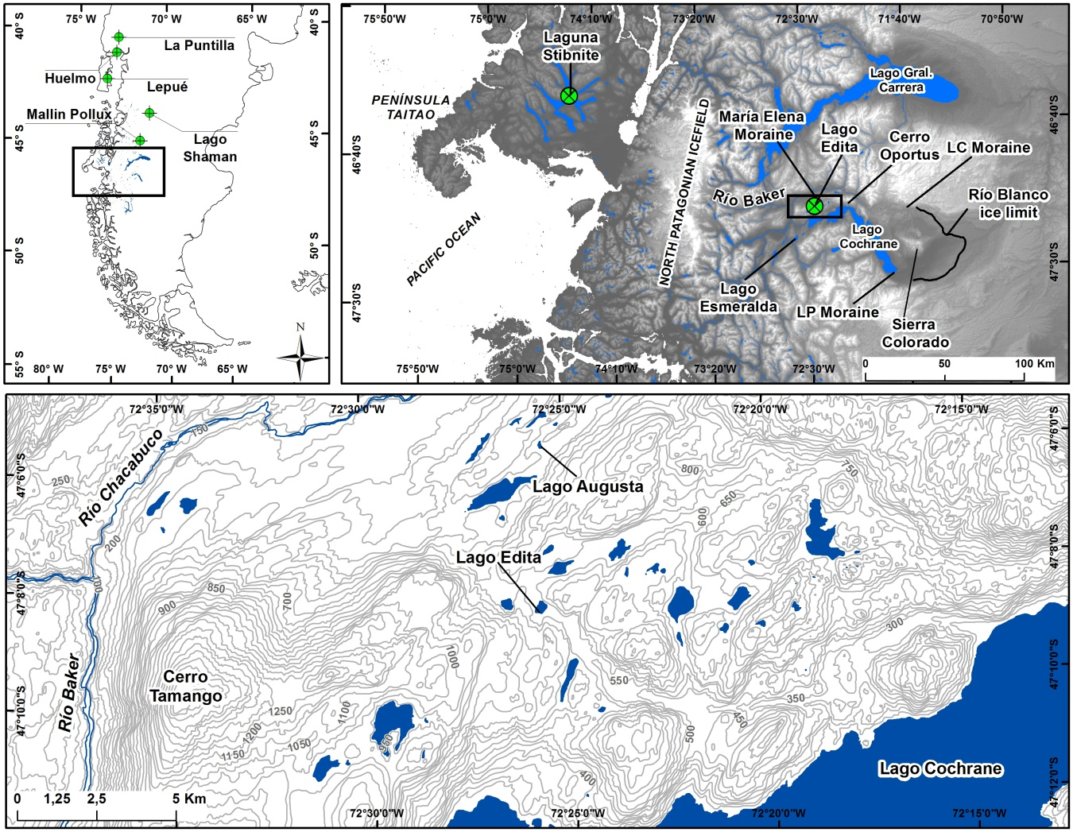

Figure 2



Figure 3



Figure 4





Figure 5

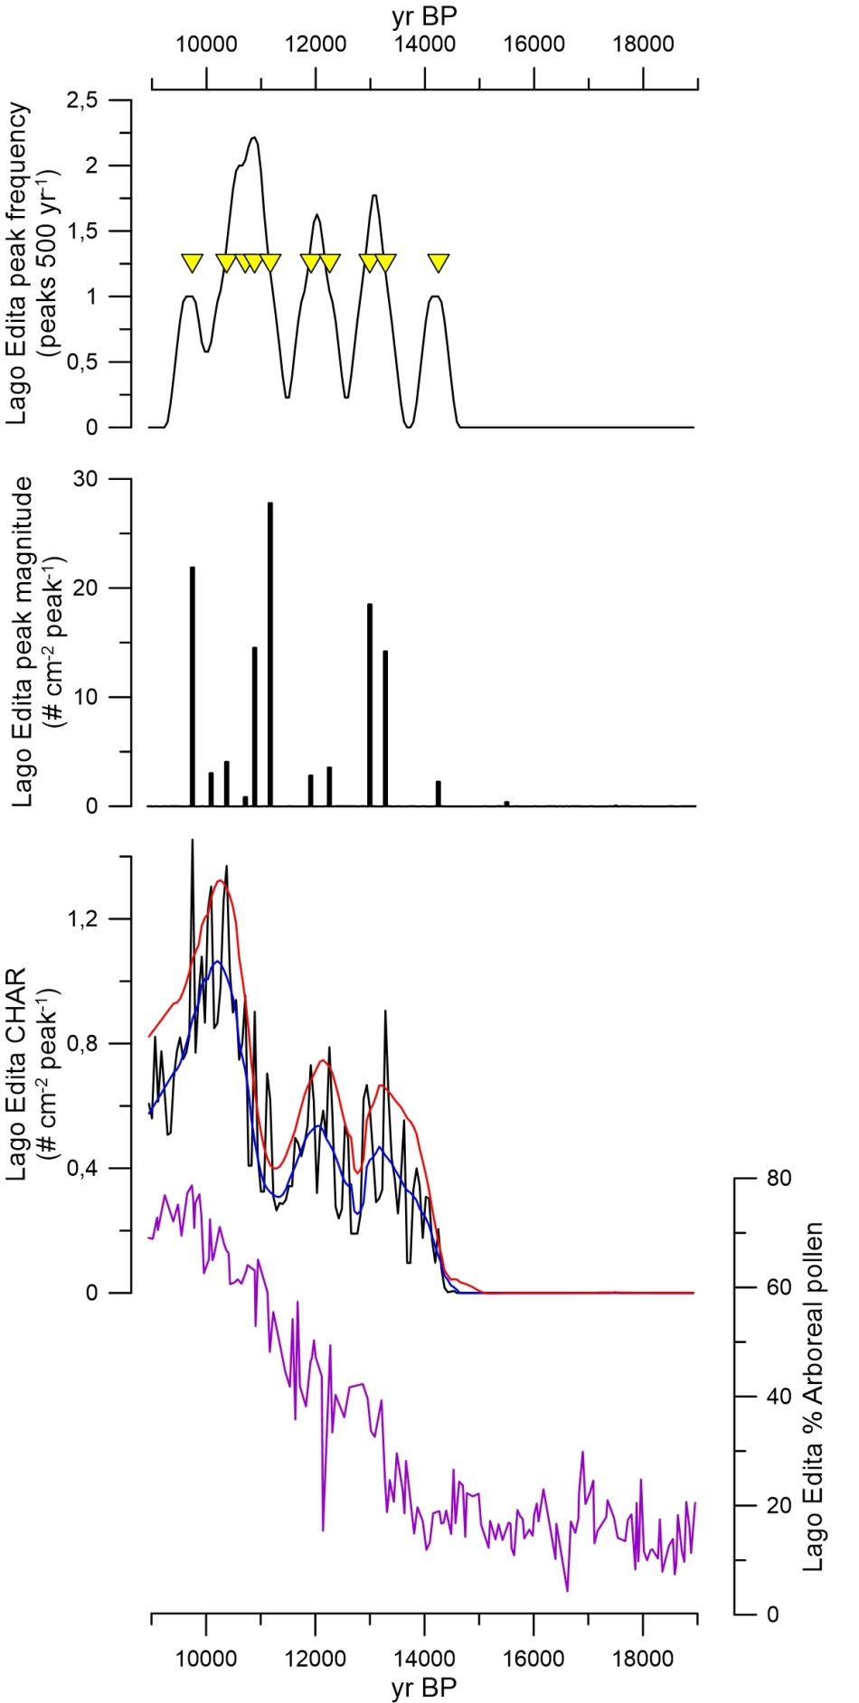

Figure 6

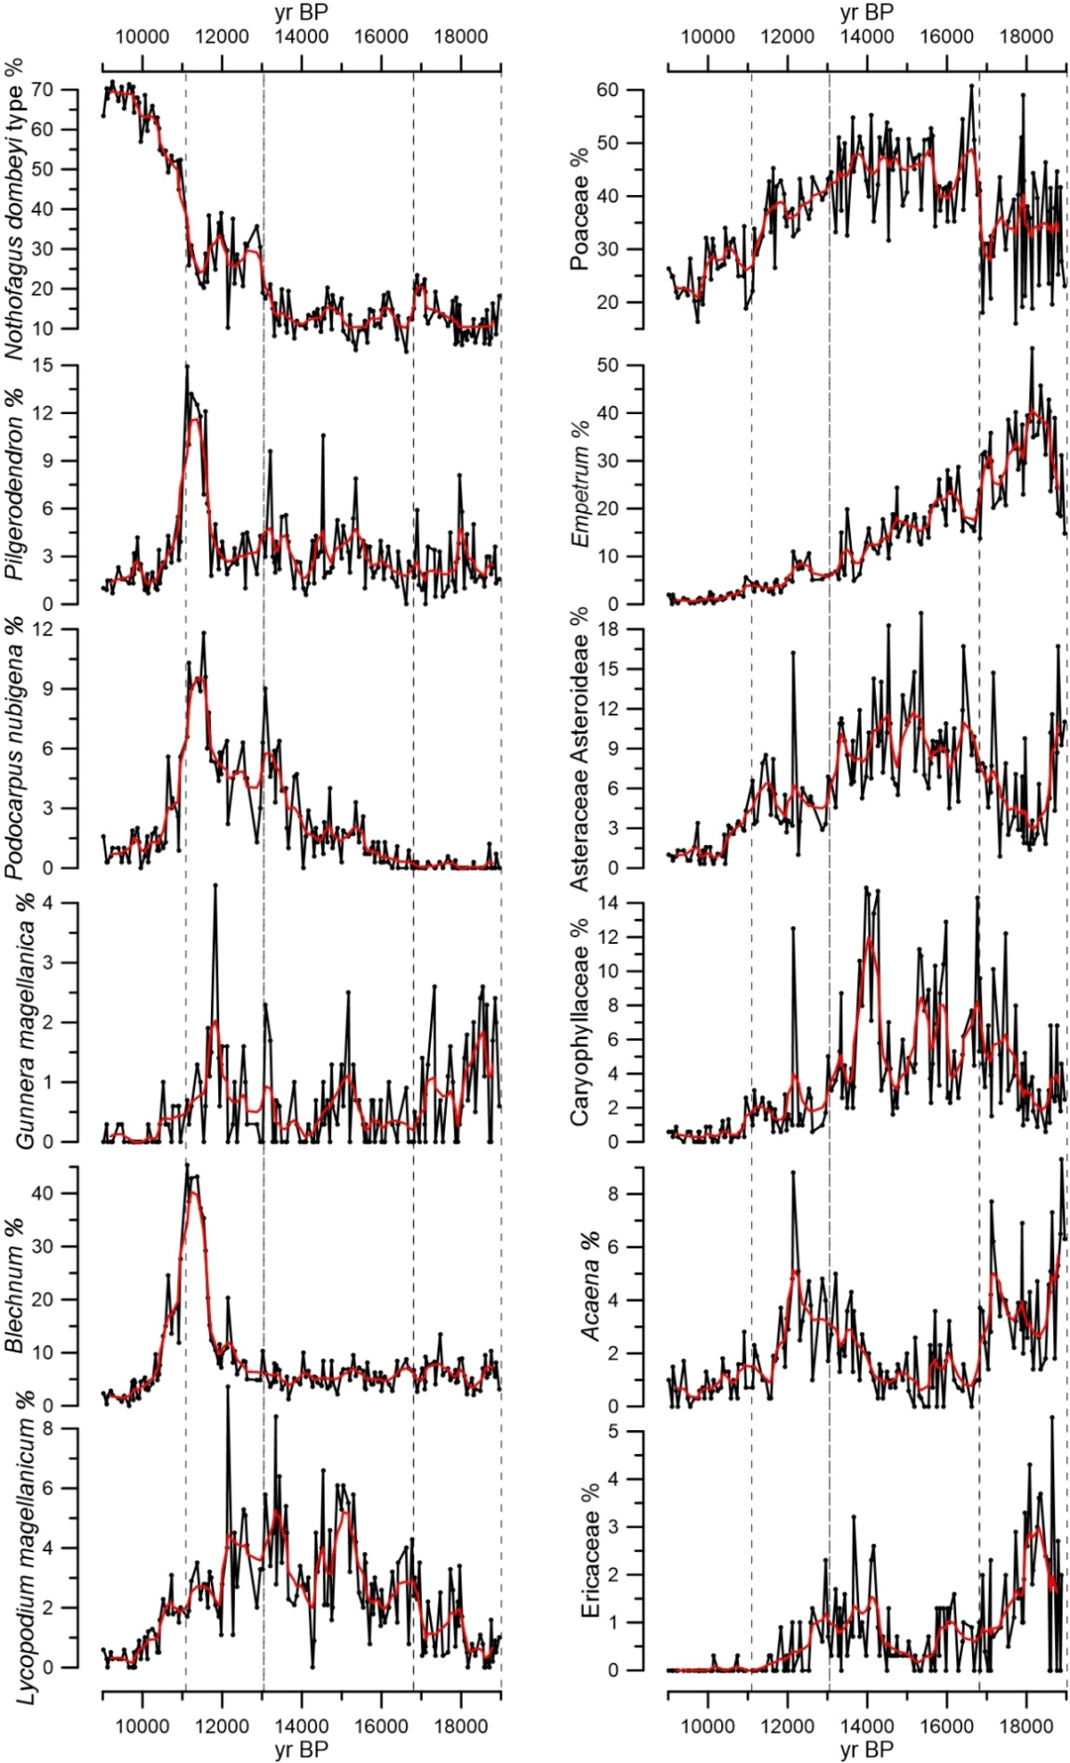

Figure 7

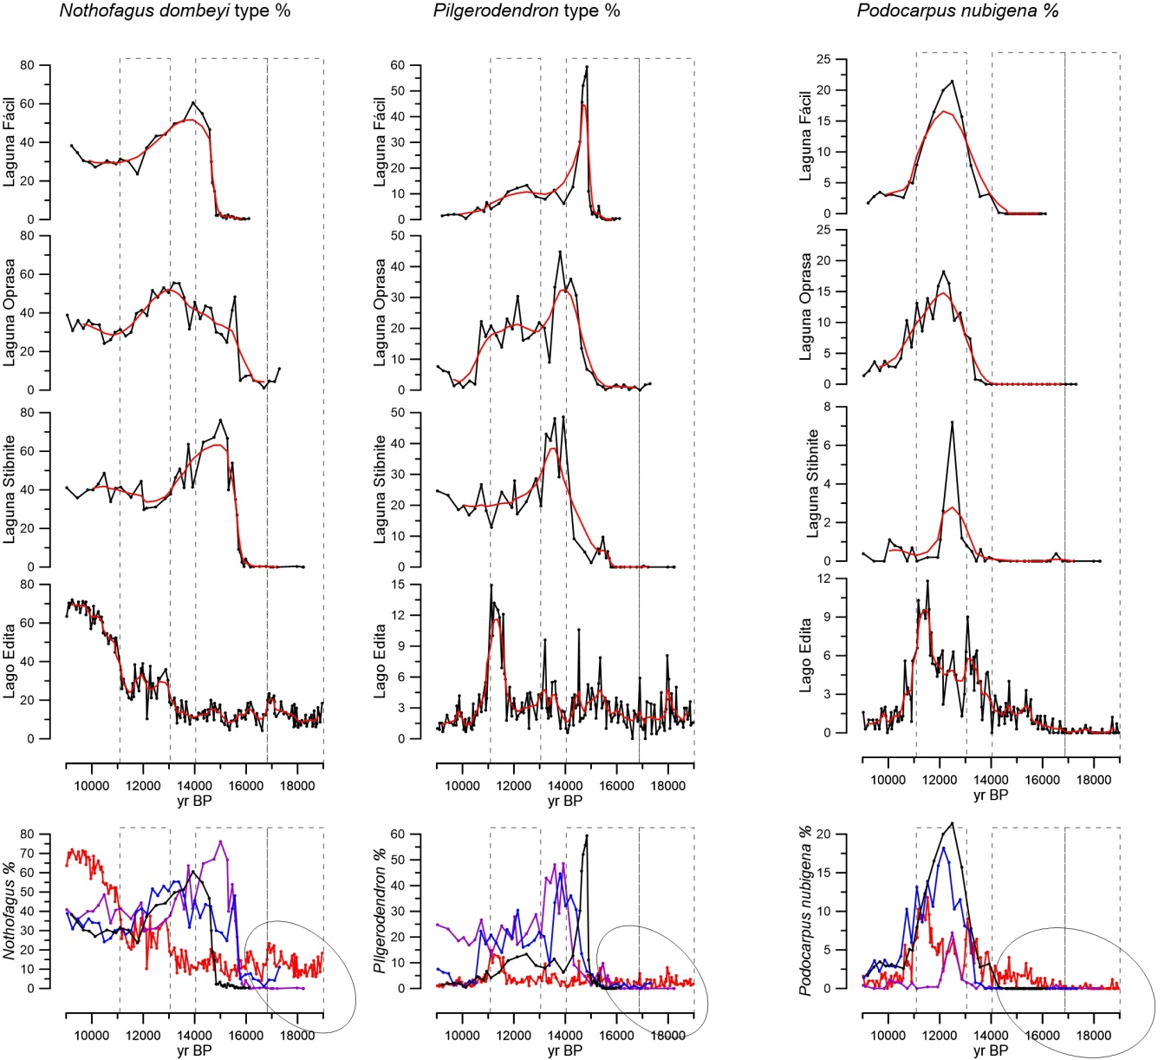

Figure 8

